A Final Dissertation Report on
Minimalist Alert Network for Threat Intelligence System

Anuskar Sigdel
UON ID: 24812606
BSc. (Hons.) Computer Science

Supervisor: Nischal Khadka
Naaya Aayam Multi-Disciplinary Institute
University of Northampton

August 2026

Abstract
This dissertation presents the design, implementation and empirical evaluation of MANTIS (Minimalist Alert Network for Threat Intelligence System), a zero-dependency host-based intrusion detection and prevention system built with the Python Standard Library. Five inspectable engines address volumetric anomalies, port scans, malicious payload tokens, behavioural novelty and IP reputation. Linux AF_PACKET capture, binary parsing, logging, UDP/JSON telemetry, a web SIEM, brain-state persistence and opt-in iptables response operate within one process. Evaluation combines 116 automated tests, constructed engine checks, a reproducible 13,159-frame PCAP scenario and all 45,018,252 rows from 63 merged CIC-IoT2023 CSV files. All software tests passed. The constructed samples verified intended code paths but were not treated as field-accuracy evidence. In the external Z-Score stress test, precision was 0.997417, recall 0.043619, F1 0.083582, balanced accuracy 0.519447 and MCC 0.029049; 42,049,152 attack rows were missed. Because attack prevalence was 0.976647, an always-positive baseline reached F1 0.988186, demonstrating that headline F1 can be misleading. The merged data provide only a non-temporal Rate feature compatible with the Z-Score engine, so the experiment tests assumption and transfer limits rather than the complete five-engine pipeline. MANTIS is therefore a functioning lightweight research artefact, but credible deployment claims require representative temporal data, prevalence-aware metrics and independent validation.
Keywords: intrusion detection; zero dependency; edge computing; machine learning; CIC-IoT2023; evaluation validity; Python

Acknowledgements
I would like to thank my supervisor, Nischal Khadka, for his guidance, patience and detailed feedback throughout every stage of this project. I am grateful to the staff of Naaya Aayam Multi-Disciplinary Institute and the University of Northampton for providing the environment and resources that made this work possible. Finally, I thank my family and friends for their constant support and encouragement during the preparation of this dissertation.
Table of Contents
Abbreviations 9
1. Introduction 11
1.1 Background 11
1.2 Rationale 11
1.3 Aim and Objectives 11
1.4 Overview of Methodology 12
1.5 Limitations 13
2. Literature Review 14
2.2 Comparable Systems 17
2.3 Research Methodology 21
2.4 Implementation Traceability 22
2.5 Development Methodology 22
2.6 Evaluation Strategy 23
2.7 Methodology for Comparable Analysis 24
2.8 Requirement Specification 25
2.9 Algorithms Implemented 38
3. System Analysis and Design 45
3.1 Use Case 45
3.2 Sequence Diagrams 49
3.3 Class Diagram 53
3.4 Activity Diagrams 55
3.5 Database Schema 60
3.6 Algorithms Implemented 60
3.7 System Interface and Design 64
4. System Build and Technical Notes 73
5. Testing Strategy and Evaluation 75
5.1 Testing Definitions and Approach 75
5.2 Algorithm Tests 76
5.3 Test Cases and Scenarios 77
6. Future Scope 86
7. Conclusion 87
8. References 88
Appendix A: Gantt Chart 90
Appendix B: Supervisor Meeting Forms 91
Appendix C: Source Code 93
Appendix D: Presentation Slide 94

List of Figures
Figure 2.1: Snort product and documentation page (Cisco Talos, 2024) 19
Figure 2.2: Suricata documentation page (OISF, 2024) 20
Figure 2.3: Zeek documentation page (Zeek Project, 2026) 21
Figure 2.4: Wazuh documentation page (Wazuh, 2026) 22
Figure 2.5: Kanban development workflow from the project plan 24
Figure 2.6: Qualitative comparable system functionality ranking using the project rubric 25
Figure 2.7: Current monitoring and manual response workflow 36
Figure 2.8: Proposed end to end MANTIS workflow 37
Figure 2.9: Z-Score statistical engine flowchart 41
Figure 2.10: K-Nearest Neighbours engine flowchart 43
Figure 2.11: Multinomial Naive Bayes engine flowchart 45
Figure 3.1a: MANTIS abstract goal level use case model 47
Figure 3.1b: MANTIS level 1 use case model with include and extend detail 47
Figure 3.2a: Live detection sequence from captured frame to operator visible alert 51
Figure 3.2b: Training pipeline from validated data to persistent engine state 52
Figure 3.2c: SIEM alert delivery and browser dashboard retrieval 53
Figure 3.2d: Offline PCAP replay and finite analysis completion 54
Figure 3.3: Corrected MANTIS class model with inheritance, composition and explicit UML multiplicities 55
Figure 3.4a: Live detection, verdict aggregation and optional response activity 56
Figure 3.4b: Training pipeline from input validation to brain export 57
Figure 3.4c: Evaluation harness and confusion matrix metric activity 58
Figure 3.4d: Corrected brain persistence and orderly shutdown activity flow 59
Figure 3.4e: Linux installation and capability configuration activity 60
Figure 3.5: Online Mini-Batch K-Means flow from explicit feature input to normal or anomaly output 63
Figure 3.6: Bloom Filter reputation membership decision flow 65
Figure 3.7a: Overview page wireframe showing system health, recent events and engine activity 66
Figure 3.7b: Packets page wireframe showing capture controls, packet history and selected frame detail 67
Figure 3.7c: Alerts page wireframe showing the complete bounded threat activity log 68
Figure 3.7d: Architecture page wireframe showing all five engines and the response path 69
Figure 3.8a: Overview page mockup with controlled health metrics, recent events and five engine activity 70
Figure 3.8b: Packets page mockup with filters, protocol counters, exports and packet detail 71
Figure 3.8c: Alerts page mockup with the complete in memory threat log and ATT&CK context 72
Figure 3.8d: Architecture page mockup documenting all five engines and policy gated response 73
Figure A.1: MANTIS constructive research methodology Gantt chart 91
Figure B.1: Supervisor meeting form, project diary and log (1 of 2) 92
Figure B.2: Supervisor meeting form, project diary and log (2 of 2) 93

List of Tables
Table 1.1: Measurable project objectives and success criteria 13
Table 2.1: Snort 3.x pros and cons 19
Table 2.2: Suricata 7.x pros and cons 20
Table 2.3: Zeek 8.x pros and cons 21
Table 2.4: Wazuh 4.x pros and cons 22
Table 2.5: Comparable system strengths and limitations 25
Table 2.6: Functional requirements with inputs and implementation logic 29
Table 2.7: Performance and environment targets for final evaluation 38
Table 3.1: Actor use case associations, include and extend 47
Table 3.2: Principal MANTIS use case documentation 49
Table 3.3: Logical to physical persistence mapping 61
Table 4.1: MANTIS build components and technical constraints 74
Table 5.1: Test levels mapped to requirements and evidence modules 76
Table 5.2: External CIC-IoT2023 Z-Score stress-test results 77
Table 5.3: Twenty eight representative executed test cases and scenarios 78
Table 5.4: Terminal execution evidence for test cases TC-01 to TC-28 80

Abbreviations
AF_PACKET | Linux raw packet socket family
API | Application Programming Interface
ATT&CK | MITRE Adversarial Tactics, Techniques and Common Knowledge
CIC | Canadian Institute for Cybersecurity
CLI | Command Line Interface
CSV | Comma Separated Values
DDoS / DoS | Distributed Denial of Service / Denial of Service
FR / NFR | Functional Requirement / Non Functional Requirement
HIDS | Host Based Intrusion Detection System
HTML | HyperText Markup Language
HTTP | HyperText Transfer Protocol
ICMP | Internet Control Message Protocol
IDS / IPS | Intrusion Detection / Prevention System
IoT | Internet of Things
IPv4 / IPv6 | Internet Protocol version 4 / version 6
JSON | JavaScript Object Notation
KNN | K Nearest Neighbours
MANTIS | Minimalist Alert Network for Threat Intelligence System
MCC | Matthews Correlation Coefficient
ML | Machine Learning
NIST | National Institute of Standards and Technology
PCAP | Packet Capture file format
PII | Personally Identifiable Information
PPS | Packets Per Second
SIEM | Security Information and Event Management
SQLi | SQL Injection
TCP / UDP | Transmission Control Protocol / User Datagram Protocol
TLS | Transport Layer Security
UML | Unified Modelling Language
VLAN | Virtual Local Area Network

1. Introduction
Small Linux and IoT hosts need monitoring but often lack resources required by established platforms. Intrusion detection monitors events for incident indicators (NIST, 2007), creating a need for transparent edge detection.

MANTIS combines five inspectable Standard Library detection methods with persistent evidence and a browser dashboard. This chapter defines its rationale, aim, objectives and evaluation approach.

1.1 Background
Resource-constrained hosts still face reconnaissance, flooding, harmful payloads and known malicious sources, while complex enterprise monitoring may be impractical.

Snort and Suricata recognise documented patterns and Wazuh provides broader management, but operational suitability also depends on resources, latency and traffic distribution (Sommer and Paxson, 2010; Neto et al., 2023).

1.2 Rationale
MANTIS tests whether complementary, understandable detectors can operate together on commodity Linux and record evidence for each alert.

AF_PACKET observations feed Z-Score, KNN, Naive Bayes, Mini-Batch K-Means and Bloom Filter engines. MANTIS persists state and exposes evidence, but does not decrypt HTTPS or replace an enterprise SIEM.

1.3 Aim and Objectives
To design, implement and critically evaluate MANTIS as a transparent, low footprint host based intrusion detection system for commodity Linux that integrates five explainable detection techniques and produces actionable security alerts using no external Python runtime packages.
Six measurable objectives link the aim to artefacts, tests and evaluation evidence.
Table 1.1: Measurable project objectives and success criteria
ID | Measurable objective | Success criterion
O1 | Define traceable requirements and acceptance checks. | Tables 2.6 and 5.3 link requirements, outcomes and evidence.
O2 | Implement five inspectable Standard Library engines. | Engine tests and brain-state round trips pass.
O3 | Integrate capture, parsing, bounded queues, evidence and policy response. | Integration tests cover malformed frames, privacy and disabled-by-default blocking.
O4 | Provide validated, reproducible training and JSON state. | Invalid schemas fail clearly; valid state restores correctly.
O5 | Evaluate software behaviour and compatible external data. | 116 tests pass; Table 5.2 reports 45,018,252 rows with recall and MCC.
O6 | Compare MANTIS with four established systems and state bounds. | Chapter 2 compares scope; conclusion states Linux, plaintext and laboratory limits.

1.4 Overview of Methodology
The implementation used Kanban, the Python Standard Library and an isolated Linux security laboratory.

1.4.1 Methodology Framework
A solo Kanban board limited work to two coding cards and one testing card. Each card linked a deliverable to acceptance evidence, and failed evaluations reopened work.

1.4.2 Technology Stack and Languages
The Python 3.6+ Standard Library provides networking, threading, persistence and HTTP support (Python Software Foundation, 2026). AF_PACKET enables Linux capture, iptables enables optional response, and offline training remains available elsewhere.

1.4.3 Development Tools and Environments
Development used Visual Studio Code or Cursor, Git and a VirtualBox laboratory containing Ubuntu and Kali hosts. unittest, PCAP evidence and the local SIEM supported verification.

1.5 Limitations
Live capture and response require Linux privileges, and encrypted payloads, authentication, IPv6 and distributed operation are excluded. Evidence includes tests, replay and a 45,018,252-row Rate stress test, not a production claim.

2. Literature Review
This chapter reviews four peer reviewed studies and four comparable systems, then converts their lessons into the methodology, evaluation strategy and requirement specification for the final artefact. Each paper is discussed in three paragraphs: the first identifies the study, where and when it was published and how it was conducted; the second explains its relevance to MANTIS; the third summarises its findings and the gap it leaves for this project.

2.1.1 Applying Generative Machine Learning to Intrusion Detection: A Systematic Mapping Study and Review
Halvorsen, Izurieta, Cai and Gebremedhin (2024) published this systematic mapping study and review in ACM Computing Surveys, volume 56, issue 10, article 257. Working from Washington State University and Montana State University, the authors define research questions, filter the candidate literature and classify the surviving studies at the intersection of generative machine learning and intrusion detection. The mapped work falls into three uses: adversarial or penetration testing, improvement of scarce and unbalanced training data, and generative models operating directly as detectors.

The study is relevant to MANTIS because it confirms the problems this project starts from: malicious samples are scarce, class distributions are unbalanced, false positives are costly and some attack behaviours cannot be collected safely. MANTIS answers within a different design space. Instead of generating traffic, it keeps five Standard Library engines whose inputs and decisions remain inspectable, records the responsible engine, label and confidence in a common Verdict, and keeps training data, replay traffic, live capture and saved brain state as separate evidence sources so prepared data is never presented as live network proof.

Findings Gap Analysis: The review finds that generative models can strengthen intrusion detection testing and training, but the mapped evidence is heterogeneous: studies generate different artefacts, evaluate different datasets and report incompatible fidelity and classification measures, and no accepted metric yet exists for the fidelity of generated security data. The remaining gap is the deployment path. The paper measures no packet latency, memory use or safe host response, so a space is left between improved experimental data and a small auditable detector processing real frames on commodity Linux, and MANTIS is built to occupy that space.

2.1.2 CICIoT2023: A Real Time Dataset and Benchmark for Large Scale Attacks in IoT Environment
Neto, Dadkhah, Ferreira, Zohourian, Lu and Ghorbani (2023) published CICIoT2023 in Sensors, volume 23, issue 13, article 5941, from the Canadian Institute for Cybersecurity at the University of New Brunswick. The authors build a documented testbed of 105 Internet of Things devices, execute 33 attacks grouped into seven families together with benign activity, and release both the attack procedures and the extracted traffic features. Five learning methods are then benchmarked at three label granularities after the records are combined, shuffled, split 80 to 20 and normalised.

The dataset is the principal external training and evaluation source for MANTIS, and the paper defines how it must be used responsibly. The loader validates the schema before any record reaches an engine, each detector receives only features whose semantics match its input, and a destination port value is rejected rather than silently substituted for the aggregated unique port count required by the scan detector. The raw capture path is tested separately from the prepared flow path, so benchmark records are never mistaken for live traffic evidence.

Findings Gap Analysis: The benchmark finds strong binary classification across the reported models, while grouped and individual attack classification degrade progressively; the decline in F1 is more informative than accuracy alone. The gap concerns generalisation and deployment. A shuffled row level split can place closely related flows in both training and testing, the controlled topology and uneven class distribution limit external validity, and the extracted CSV features are not the raw Ethernet frames MANTIS parses. The study also measures nothing about queue behaviour, state persistence or alert delivery, which the MANTIS test suite covers instead.

2.1.3 Machine Learning Based Intrusion Detection System: An Experimental Comparison
Hidayat, Ali and Arshad (2023) published this experimental comparison in the Journal of Computational and Cognitive Engineering, volume 2, issue 2, pages 88 to 97. Working across Edinburgh Napier University, the University of Glasgow and Glasgow Caledonian University, the authors preprocess the TON_IoT records, select features using Pearson correlation and a Random Forest model, and compare Decision Tree, KNN and AdaBoost alongside MLP and LSTM under a 75 to 25 split, reporting accuracy, precision, recall, F1 and ROC behaviour.

The paper informed two MANTIS decisions. First, KNN is adopted only as a scan oriented component whose feature vector, scaling, neighbour votes and confidence are all recorded, rather than as a universal intrusion classifier. Second, evaluation must report several measures and computational cost together, because the authors show that the best scoring model is not automatically the most deployable; AdaBoost reaches the highest accuracy but takes substantially longer to train and test. MANTIS therefore reports per engine metrics with the environment and sample sizes stated.

Findings Gap Analysis: The reported accuracies of 99.6, 99.0 and 99.8 percent for Decision Tree, KNN and AdaBoost show that prepared TON_IoT tables separate well. The gap is the distance from a live sensor. A single random split from one source cannot test unseen attack families, capture periods or environments, and the study integrates no packet acquisition, online feature windows, bounded queuing, persistence or response path. Its selected flow columns are also not guaranteed to exist during live AF_PACKET analysis, which is why MANTIS validates every training column explicitly before use.

2.1.4 A False Sense of Security? Revisiting the State of Machine Learning Based Industrial Intrusion Detection
Kus, Wagner, Pennekamp, Wolsing, Fink, Dahlmanns, Wehrle and Henze (2022) presented this study at the 8th ACM Cyber Physical System Security Workshop, published by ACM in New York. Instead of allowing every attack type to appear in both training and testing, their method withholds individual attacks or complete categories from training and then measures whether several literature derived industrial intrusion detection classifiers still recognise the withheld behaviour on process level datasets.

This paper shaped how MANTIS reports its own results. Functional test passes are kept separate from precision, recall, F1 and MCC; K-Means distance is described as behavioural novelty rather than verified zero day detection; engines can withhold observations already judged anomalous so a sustained attack cannot redefine the baseline as normal; and the conclusion never converts 116 passing software tests into a field accuracy claim. The paper also defines the evaluation MANTIS still requires in future work: withholding attack families, devices and time periods before claiming generalisation.

Findings Gap Analysis: The central finding is that scores near 99 percent under familiar random splits can collapse to detection rates between 3.2 and 14.7 percent for specific withheld attacks, because the evaluated models learn signatures of attacks present in training rather than stable properties of normal behaviour. The gap is constructive rather than solved: the study critiques evaluation practice on industrial datasets but builds no lightweight Linux monitoring artefact and does not close the generalisation problem it exposes, so its warning applies to any small verification set, including the one used in Chapter 5 of this report.

2.2 Comparable Systems
Four established systems were selected because they represent different monitoring approaches: signature inspection, multithreaded network security monitoring, behavioural telemetry and host centred security analytics. Each system is considered separately using the interim report pattern of a short evaluation, an official product or documentation figure, and a dedicated pros and cons table. The comparison focuses on relevance to MANTIS rather than declaring an overall market winner.

2.2.1 Snort 3.x
Snort 3.x is a mature network intrusion detection and prevention system whose rules describe traffic conditions and the action to take when they match. Its rule language, protocol inspection and large community ruleset make it a strong reference for deterministic and explainable detection (Cisco Talos, 2024). For MANTIS, Snort demonstrates the operational value of auditable rules and inline response. Its limitation is that learning and anomaly detection are not native equivalents of the five trainable or adaptive engines investigated by this project.
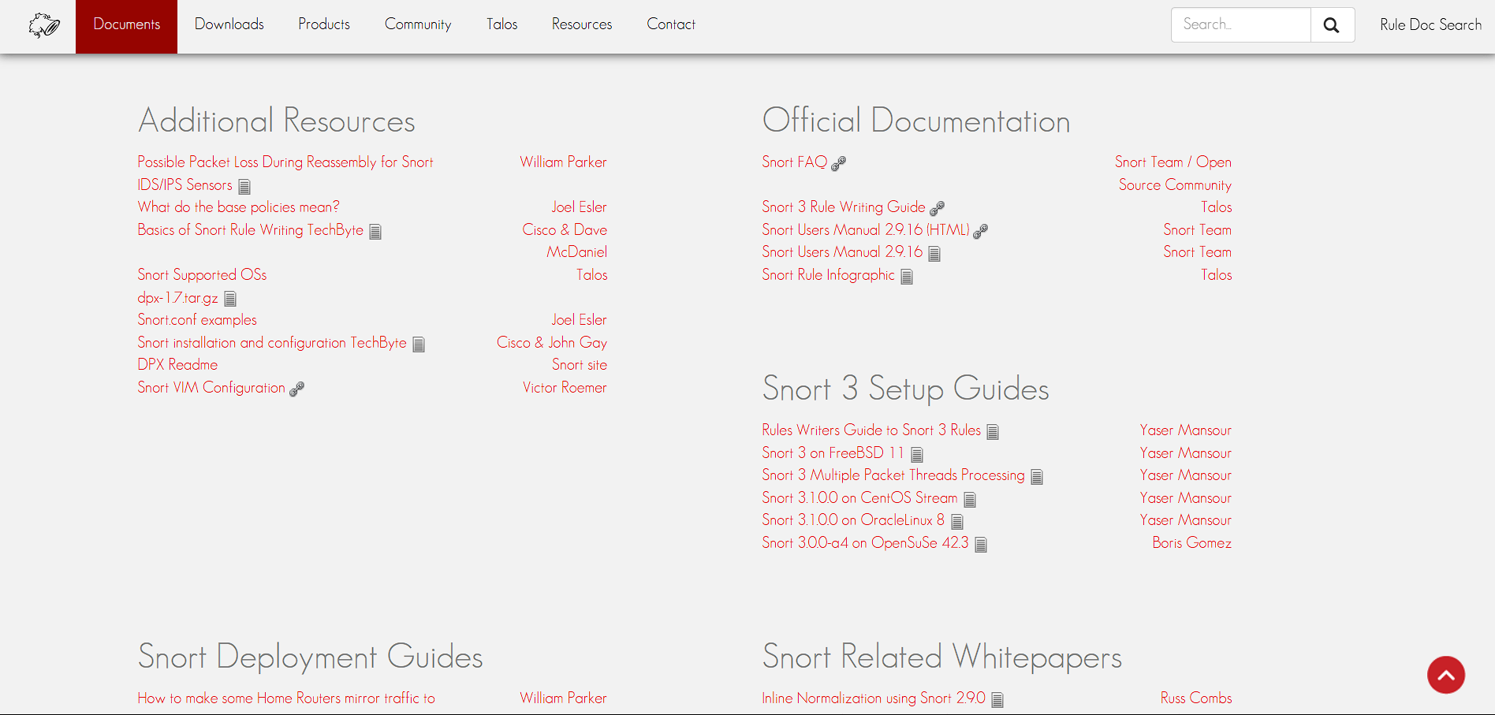
Figure 2.1: Snort product and documentation page (Cisco Talos, 2024)
Table 2.1: Snort 3.x pros and cons
Pros | Cons
• Mature signature language and rules ecosystem | • No native trainable anomaly engine comparable to MANTIS
• Deep packet and protocol inspection | • Rule quality and maintenance directly affect coverage
• Supports passive detection and inline prevention | • Unknown behaviour may not match an existing signature
• Deterministic matches are straightforward to audit | • Build and deployment are broader than a Standard Library prototype
2.2.2 Suricata 7.x
Suricata 7.x is an open-source network threat detection engine designed for modern multithreaded processing. It supports IDS, IPS and network security monitoring functions and exposes rich EVE JSON events that integrate well with external analytics (OISF, 2024). This structured output is an important design reference for MANTIS telemetry. However, Suricata remains primarily a rules and protocol inspection platform; machine learning workflows normally sit outside the core engine, whereas MANTIS makes its five small detection models part of the artefact being studied.
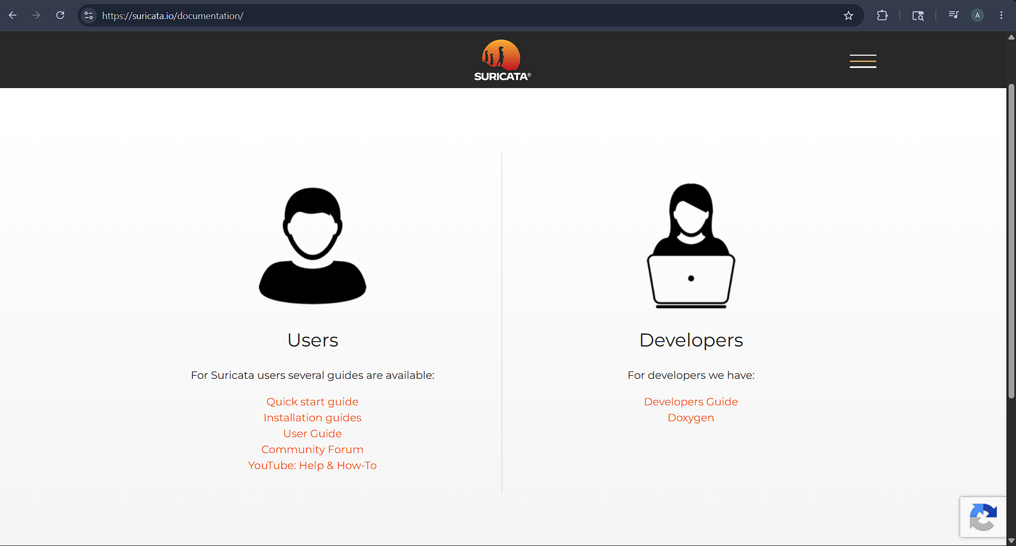
Figure 2.2: Suricata documentation page (OISF, 2024)
Table 2.2: Suricata 7.x pros and cons
Pros | Cons
• Multithreaded architecture supports high throughput inspection | • Learning normally requires an external analytics pipeline
• EVE JSON provides structured alerts and flow records | • Signature coverage still depends on rules and configuration
• Broad protocol and file inspection capabilities | • Its feature scope is larger than the project’s minimalist target
• Can operate as IDS, IPS or monitoring sensor | • Operational tuning is more complex than a small teaching prototype
2.2.3 Zeek 8.x
Zeek 8.x is a network security monitoring framework that converts traffic into detailed protocol logs and events which analysts can extend through its scripting language. Its behavioural visibility and event driven design make it a valuable comparison for anomaly oriented monitoring (Zeek Project, 2026). Zeek’s strength is not a single classifier but the context it exposes for analysis. It does not provide native inline blocking as its central purpose, so response is normally coordinated through another control mechanism or security platform.

Figure 2.3: Zeek documentation page (Zeek Project, 2026)
Table 2.3: Zeek 8.x pros and cons
Pros | Cons
• Detailed protocol logs support behavioural investigation | • Inline prevention is not its principal operating model
• Event driven scripting enables custom detection policies | • Effective deployments require scripting and policy expertise
• Strong visibility for incident analysis and hunting | • External components are commonly used for enforcement
• Transparent scripts can be reviewed and versioned | • It does not provide MANTIS style trainable engines as one compact bundle
2.2.4 Wazuh 4.x
Wazuh 4.x is a broader open source security platform built around agents, a central server, an indexer based on OpenSearch and a dashboard. It combines endpoint telemetry, rule based analysis, central management and configurable active response (Wazuh, 2026). These capabilities make it suitable for distributed monitoring, but its purpose and deployment scale differ from a single lightweight network sensor. The comparison is therefore about architectural scope: Wazuh offers platform integration, while MANTIS concentrates on inspectable detection algorithms and a small experimental runtime.
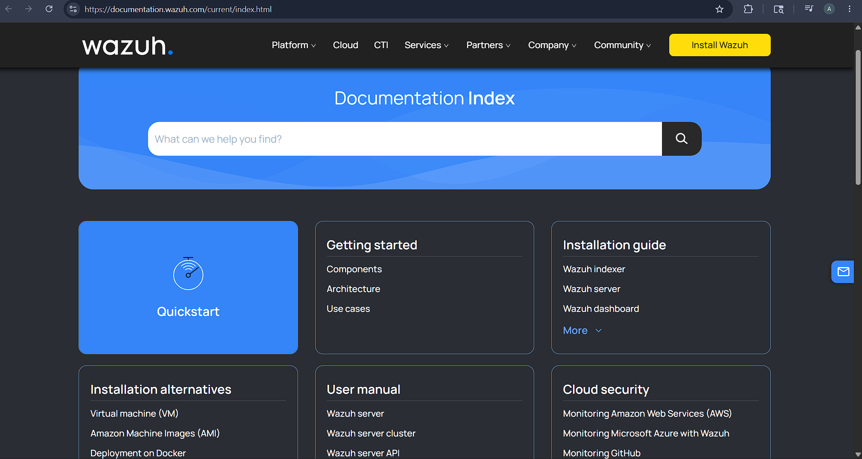
Figure 2.4: Wazuh documentation page (Wazuh, 2026)

Table 2.4: Wazuh 4.x pros and cons
Pros | Cons
• Centralised management for distributed agents | • Multi component stack has a larger operational footprint
• Rules, decoders, dashboards and active response | • Deployment and maintenance exceed a single sensor prototype
• Searchable security event storage and correlation | • Network anomaly learning is not its sole design focus
• Suitable for wider endpoint and compliance monitoring | • Central services create more configuration and security responsibilities

2.3 Research Methodology
The project uses constructive research methodology, in which knowledge is produced by building and evaluating an artefact that answers a defined practical problem (Crnkovic, 2010). Requirements are derived from literature, comparable systems and the deployment context; the artefact is then built and evaluated against those requirements, creating a traceable chain from research challenge to design decisions, implementation evidence and final critique.
The methodology combines artefact construction with empirical evaluation. Quantitative evidence includes unit and integration results, per engine confusion matrices, precision, recall, F1 score, latency, throughput and resource measurements. Qualitative evidence is limited to structured usability observations and architectural critique. This mixed evidence is used to judge fitness for the stated low resource research context, not to claim equivalence with mature commercial or community platforms.

2.4 Implementation Traceability
A pragmatic philosophy is appropriate because the research question is concerned with whether a transparent, low footprint detector can be built and evaluated usefully under practical constraints. The project therefore selects methods according to the evidence needed for that question. Mathematical inspection explains how decisions are produced, tests show whether components behave as specified, and measurements show how the integrated artefact performs in a stated environment.

Pragmatism does not remove methodological control. Dataset origin, preprocessing, configuration, operating system, hardware and test conditions are reported so that results can be interpreted and repeated, and claims are restricted to the tested implementation and environment. Conditions that were not evaluated, such as unknown operational traffic, encrypted payloads and adversarial evasion, are treated as limitations rather than inferred strengths.

2.5 Development Methodology
Development used Kanban with a work in progress limit of two coding cards and one testing card. Each card named a module, an acceptance test and an evidence file. Engine cards mapped to src/engines and test_engines.py; capture and parser cards mapped to sensor.py, parser.py and test_integration.py; SIEM cards mapped to siem.py and test_siem_api.py. Failed evaluation cards returned to In Progress.
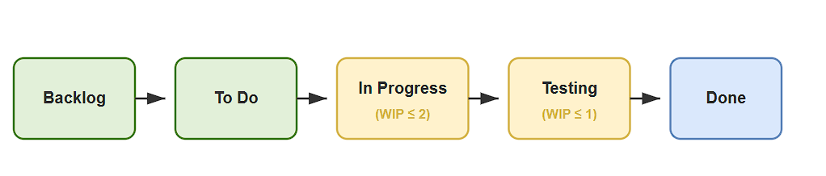
Figure 2.5: Kanban development workflow from the project plan
The board was refined during implementation: engine defect cards were reopened after evaluation, SIEM tests were added and privacy checks moved to the dispatcher. The full project Gantt chart is reproduced in Appendix A, and progress against it is evidenced by the mapped modules and the 116 test suite.

Each item is completed through a short build and verify cycle: define an acceptance condition, implement the smallest coherent change, test it at the appropriate level, record evidence, and update the dissertation or project log. The approach keeps the final artefact linked to the proposal and interim milestones while allowing requirements to be corrected when the code, platform or evaluation data contradicts an earlier assumption.

2.6 Evaluation Strategy
Evaluation is organised in layers. Unit tests examine packet parsing, engine calculations, configuration and state serialisation. Integration tests examine the path from parsed traffic through engine verdicts, dispatch, logging, UDP telemetry, dashboard ingestion, optional response and PCAP export. System tests use controlled replay and live loopback traffic to verify end to end behaviour without exposing public networks or relying on uncontrolled attack activity.

Detection quality is reported separately for applicable engines using true positives, false positives, true negatives, false negatives, precision, recall and F1 score. Runtime evaluation records latency, traffic rate, CPU, memory and test environment together, because an isolated latency value is not interpretable without load and hardware. Training and testing data are separated before model fitting. Results that use small synthetic samples are labelled as functional checks, while claims about detection effectiveness require an adequately sized held out dataset.

2.7 Methodology for Comparable Analysis
The comparable analysis uses five project defined criteria: anomaly detection support, active response, suitability for a low footprint deployment, transparency of decision logic, and support for training or adaptation. Each system is assigned a qualitative alignment score from 1 to 5, where 1 indicates weak alignment with the MANTIS research context and 5 indicates strong alignment. The chart is a requirements oriented rubric based on documented capabilities; it is not a throughput benchmark or an independent product ranking.
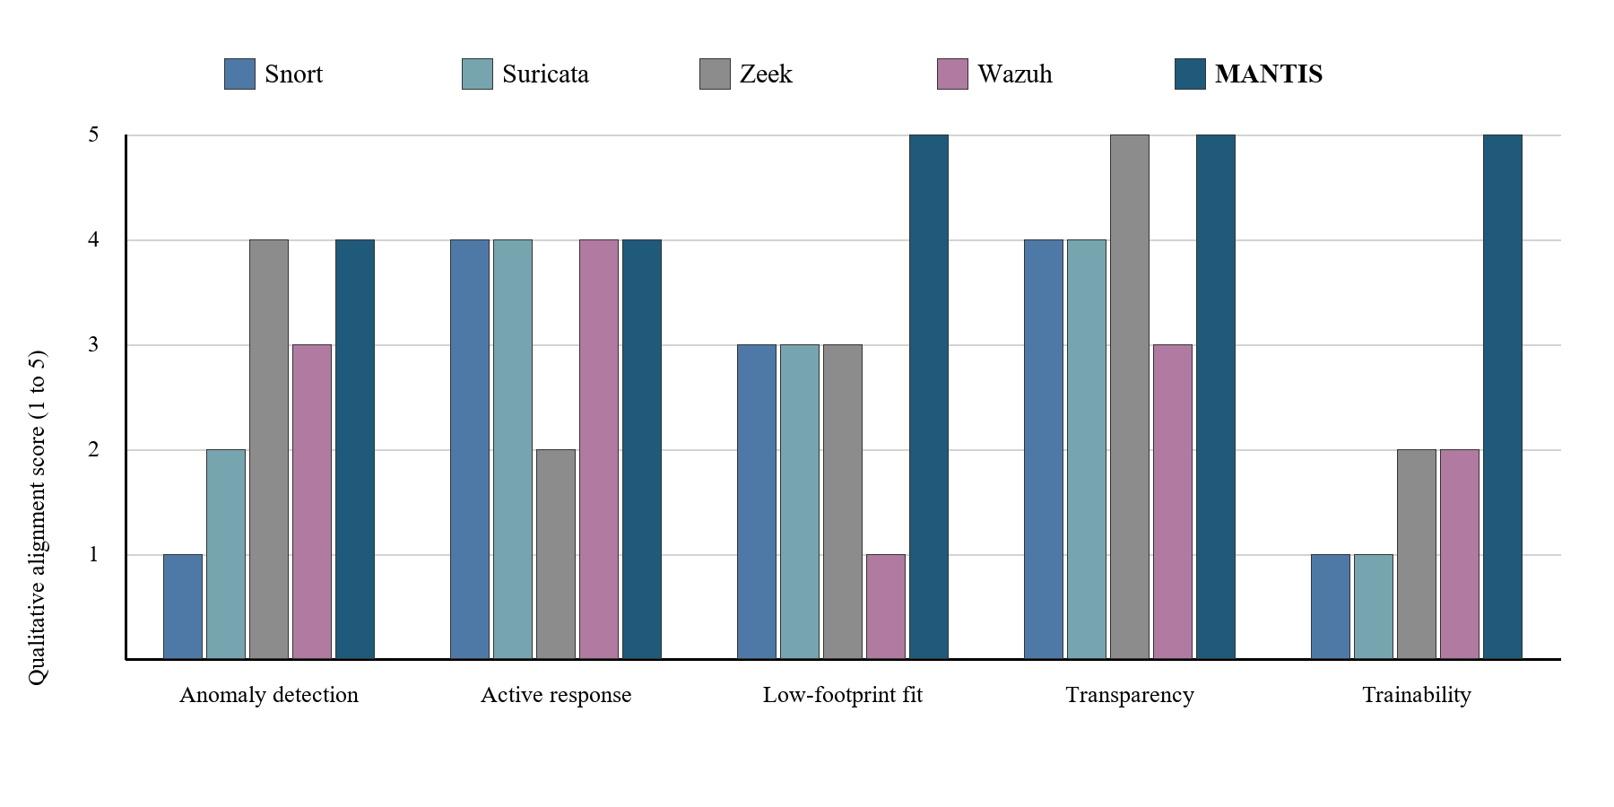
Figure 2.6: Qualitative comparable system functionality ranking using the project rubric

Table 2.5: Comparable system strengths and limitations
System | Principal strength | Limitation in the MANTIS context
Snort 3.x | Mature rule language and deep packet inspection | No native learning or anomaly model; deployment centres on rule maintenance
Suricata 7.x | Multithreaded inspection with structured EVE JSON output | Learning normally depends on an external analytics component
Zeek 8.x | Rich behavioural telemetry and scriptable protocol analysis | Detection and response policies require scripting and external enforcement
Wazuh 4.x | Centralised agent management, correlation and active response | Multi component platform is broader and heavier than a small standalone sensor
MANTIS | Five inspectable engines, training, state persistence and optional response in one prototype | Narrower protocol coverage and less operational maturity than established platforms
The comparison shows why MANTIS is a focused experimental artefact rather than a replacement for the four systems: Snort and Suricata offer greater signature and protocol maturity, Zeek provides richer behavioural telemetry, and Wazuh offers broader central management. The final evaluation therefore tests only the low footprint, inspectable criteria deliberately built into the MANTIS scope and acknowledges the prototype's narrower coverage and lower operational maturity.

2.8 Requirement Specification
The literature gaps and comparable system findings are converted below into requirements that can be traced to implementation and evaluation evidence. Functional requirements state what the artefact must do; non functional requirements state the qualities and constraints under which those functions should operate. Measurements are presented as targets at this stage and will be reported as results only after final testing.

2.8.1 Problem Domain
MANTIS addresses network monitoring on commodity Linux hosts where a learner or small operator needs inspectable detection without deploying a full security platform. The problem is defined by the following linked constraints:
- The runtime should remain small enough for a modest virtual machine, teaching laboratory, or edge Linux host, without requiring third-party Python packages for detection.
- Signature-only monitoring may miss behaviour without a prepared rule, while opaque models make it difficult to explain why an alert was generated.
- Capture, alerting, persistence, evaluation, and optional response should form one reproducible workflow, while privileged actions and sensitive payload collection remain controlled.
- Reconnaissance, volumetric anomalies, malicious payloads, behavioural novelty, and known malicious indicators require complementary detection mechanisms rather than a single universal classifier.
- Operators should be able to trace every alert to observable features, a stated threshold or learned state, and a documented decision path.
- Labelled training data, replay traffic, and live network behaviour differ, so the evidence should distinguish implementation verification from claims of real-world accuracy.
- Packet payloads and addresses may expose personal or confidential information, so data minimisation, redaction, bounded retention, and controlled export are required.
- Learned engine state and audit evidence should survive an orderly restart without silently accepting corrupted or incompatible brain data.
- Claims about detection, response, and resource use should be reproducible through traceable tests, explicitly defined environments, and reviewable output artefacts.
2.8.2 Proposed Solution Strategy
Each constraint in Section 2.8.1 is answered below by a corresponding solution decision. Keeping the same order and number makes the link from the problem domain to implementation explicit:
- MANTIS uses Python Standard Library detection code, bounded queues and buffers, compact online state, and configurable retention limits so that it can operate on a modest Linux host.
- The system combines transparent statistical, supervised, probabilistic, clustering, and membership methods instead of relying solely on prepared signatures or an opaque end-to-end model.
- Capture, parsing, five-engine analysis, alert dispatch, persistence, SIEM delivery, reporting, and optional active response are connected through a single producer-consumer workflow with controlled privileges.
- Complementary mechanisms are assigned to the principal threat patterns, with Z-Score detecting volumetric anomalies, KNN identifying reconnaissance, Naive Bayes analysing malicious payloads, K-Means recognising behavioural novelty, and Bloom Filter checking known malicious indicators.
- Each engine returns a common Verdict containing the responsible engine, label, confidence, threat flag, and decision details, while thresholds, features, and learned states remain inspectable.
- Training data, controlled PCAP replay, live observations, and evaluation artefacts are separated, while dataset schemas are validated and each result is clearly identified as evidence of either implementation behaviour or wider detection accuracy.
- Retained payloads are minimised, credentials and email addresses are redacted before persistence or telemetry, packet storage is bounded, and evidence can only be exported through controlled functions.
- All five engine states are exported to JSON during an orderly shutdown, while only compatible brain data is loaded at startup and the system safely returns to an initialised state when a valid snapshot is unavailable.
- Requirements are traced to unit, integration, system, regression, and training tests, with reviewable outputs preserved and accuracy, latency, CPU usage, and memory consumption measured only under an explicitly documented environment and workload.
Together, these nine decisions provide one implementation response for every problem domain constraint. The mapping also separates completed technical controls from performance and field accuracy claims that still require controlled measurement.

2.8.3 Alternative Solution Strategy
Three alternative approaches were considered but not selected as the main dissertation artefact:
- Extending Snort or Suricata with an external learning component would provide mature packet inspection, but the research contribution would shift toward integration with a large existing engine rather than implementation and evaluation of transparent algorithms.
- Using scikit-learn, ONNX Runtime or a neural framework would shorten model development and support more complex algorithms, but it would introduce runtime dependencies and reduce the project’s emphasis on first principles, inspectable implementation.
- Deploying Wazuh would provide broader endpoint management and response, but its multi component platform addresses a different operational scale from the single host experimental sensor defined by the aim.
These alternatives remain valid engineering choices outside the dissertation boundary. The selected strategy is justified only for the stated research purpose: to examine what can be achieved with a compact Standard Library runtime and five visible decision mechanisms.

2.8.4 Functional Requirements
Table 2.6 records the implemented functional requirements. Inputs and logic are taken from the MANTIS source modules rather than from an aspirational specification.

Table 2.6: Functional requirements with inputs and implementation logic
Sub Category | Goal / Objective | Required Inputs | Implementation Details / Logic
Packet acquisition | Capture live Ethernet frames or replay a finite PCAP without stopping the analyser on unsupported frames. | Linux interface name or PCAP path; AF_PACKET raw socket or libpcap format file; optional VLAN/ICMP frames. | SensorNode binds SOCK_RAW/AF_PACKET or opens the PCAP stream. PacketParser unpacks Ethernet/IPv4/TCP/UDP/ICMP with struct; truncated frames are rejected and counted, not fatal.
Pipeline decoupling | Prevent capture stalls when classification is slower than arrival rate. | Raw frame bytes; configured queue size; producer and analyser threads. | A bounded queue.Queue receives frames from the sniffer. On overflow the sniffer drops and records loss. The analyser dequeues, parses and fans observations to the engines.
Five engine classification | Detect volumetric floods, reconnaissance, malicious plaintext payloads, behavioural novelty and known bad sources through one contract. | Per interval PPS and unique port counts; payload bytes; source IP; trained or seeded engine state. | Each engine implements analyse/train/export_brain/import_brain. Interval engines (Z-Score, KNN, K-Means) run once per second; Bloom and Naive Bayes run per packet. A Verdict {label, confidence, detail, is_threat} is returned.
Training and brain persistence | Fit applicable engines from labelled data and restore inspectable state after restart. | CSV/JSON/CIC-IoT2023 derived tables with validated columns (unique_ports, packet_count, payload, label); brain JSON path. | training.train and Loader reject illegal mappings such as raw Dst Port as unique_ports. Compatible sections of the newest brain file are imported at start; export occurs on orderly shutdown.
Alert construction | Produce an auditable alert that an operator can explain. | Engine Verdict; packet 5 tuple; optional payload excerpt; MITRE mapping tables. | AlertDispatcher deduplicates, enriches ATT&CK technique/severity/risk, truncates excerpts to 64 bytes and redacts PII before any sink is written.
Persistence and telemetry | Retain a forensic trail and notify a SIEM without blocking capture. | Sanitised alert record; CSV path; UDP host/port default 9999. | Logger appends a locked CSV row. UDPSender emits JSON datagrams. Failures are logged; they do not terminate the analyser.
Operator interface | Display current alerts, evidence and exports in a browser. | HTTP GET on port 8080; in memory alert buffer; packet store identifiers. | siem.py serves HTML/JSON from a standard library HTTP server. Malformed UDP is discarded. The dashboard is a local prototype and is not authenticated.
Optional active defence | Block a confirmed source only under explicit operator policy. | --block flag; --block-on categories; whitelist; source IP; iptables availability. | ActiveDefense inserts iptables -I INPUT 1 -s IP -j DROP only when enabled, category permitted, not whitelisted and not already blocked. flush() removes MANTIS rules on exit.
Evidence export | Support post incident review and external analysis. | Session alerts; bounded packet store; shutdown event. | ReportGenerator writes forensic HTML. Packet evidence can be exported as a valid PCAP. Stores are bounded to prevent unbounded RAM growth.
Evaluation reporting | Produce reproducible confusion matrix metrics for applicable engines. | Held out labelled samples; imported brain state; output path. | evaluation.evaluate writes TP/FP/TN/FN, precision, recall, F1 and related files. Small synthetic sets are labelled as functional checks, not field accuracy.
Configuration and shutdown | Control runtime behaviour and release resources cleanly. | CLI/config options for interface, ports, brain, logs, PCAP and defence; stop signal. | Config supplies defaults. Shutdown stops threads, closes sockets, exports brain state and completes the HTML report.
- FR1: Capture Ethernet frames on a configurable Linux interface using AF_PACKET, while supporting offline PCAP replay when live capture is unavailable.
- FR2: Parse the Ethernet, IPv4, TCP and UDP fields required by the detection pipeline and minimise retained payload data according to configuration.
- FR3: Decouple capture and analysis through a bounded queue and record dropped frame information when the analyser cannot keep pace.
- FR4: Apply the Z-Score, KNN, Multinomial Naive Bayes, Mini-Batch K-Means and Bloom Filter engines through a common analysis contract.
- FR5: Train applicable engines from supported labelled CSV or JSON data, validate required columns, and reject incompatible feature mappings with a clear error.
- FR6: Export and import the state of all five engines as JSON safe brain data, including controlled loading at sensor start and export at shutdown.
- FR7: Create a structured alert containing time, source, destination, protocol, engine, verdict, confidence and a privacy limited payload excerpt where applicable.
- FR8: Persist alerts to an append only CSV audit log and forward structured JSON telemetry to a configurable UDP endpoint, defaulting to port 9999.
- FR9: Provide a browser dashboard on a configurable HTTP port, defaulting to 8080, for current alerts, severity, packet store evidence and permitted exports.
- FR10: Support optional iptables blocking of an alerted source only when active defence is explicitly enabled, and avoid duplicate rules for the same address.
- FR11: Generate a forensic HTML report from collected alerts during orderly shutdown.
- FR12: Evaluate applicable engines using confusion matrix counts, precision, recall and F1 score, with results written to reproducible output files.
- FR13: Expose configuration through documented command line and configuration file options, including interface, remote host, ports, brain path, logs and PCAP capture.
- FR14: Export a valid PCAP representation of captured or replayed packet evidence that can be opened by standard analysis tools.
- FR15: Decode supported VLAN tagged and ICMP frames, and reject truncated or unsupported frames without terminating the analyser.
- FR16: Maintain a bounded in memory packet store for dashboard inspection and PCAP export without unbounded memory growth.
- FR17: Enrich alerts with mapped ATT&CK technique, severity, confidence and bounded risk score while preserving the originating engine rationale.
- FR18: Expose alert, packet, statistics, configuration and export data through the local SIEM HTTP interface and reject malformed UDP telemetry safely.
- FR19: Enforce response policy through enabled state, whitelist and duplicate rule checks, and record whether an alert was flagged or blocked.
- FR20: Load threat intelligence indicators from a documented feed format, ignore comments and report missing or invalid feeds without crashing.
- FR21: Attribute interval based alerts only when a source exceeds the dominance threshold, preventing distributed traffic from being assigned to one host.
- FR22: Perform orderly shutdown by stopping worker threads, closing capture and output resources, exporting brain state and completing forensic reporting.

2.8.5 Non-Functional Requirements
- NFR1 Performance: Meet the latency, CPU and memory targets in Table 2.7 under a documented reference load and environment.
- NFR2 Transparency: Keep each engine’s mathematics, thresholds, features and state visible in source code and report per engine results.
- NFR3 Portability: Require only the Python Standard Library for detection logic; use documented Linux facilities for live capture and response; keep offline training and replay usable on other operating systems where supported.
- NFR4 Security: Disable active defence by default, validate externally supplied paths and data, minimise payload retention, and avoid exposing dashboard or UDP services directly to an untrusted network.
- NFR5 Reliability: Bound queues and buffers, handle malformed packets and telemetry without terminating the service, and preserve valid logs and brain data across controlled shutdown.
- NFR6 Maintainability: Implement engines as separate modules sharing analyse, train, export_brain, import_brain and reset operations, with automated tests for their contracts.
- NFR7 Usability: Provide documented installation, command help, clear configuration defaults and operator readable alerts without requiring an external database or web framework.
- NFR8 Reproducibility: Record dataset, split, configuration, software version, hardware and test commands for every reported experiment.

2.8.6 Goals of Implementation
The implementation goal is one coherent, inspectable and testable MANTIS prototype rather than a collection of disconnected algorithms. Capture, parsing, five detection mechanisms, alert dispatch, privacy controls, state persistence, evidence export, evaluation and the four page operator console exchange data through explicit interfaces. Completion is judged through the following goals, each linking an input, an implemented responsibility and verification evidence:
• Acquisition goal: accept live Ethernet frames through Linux AF_PACKET and finite offline PCAP input, validate supported Ethernet, VLAN, IPv4, TCP, UDP and ICMP structures, and reject malformed or unsupported frames without stopping the analyser.
• Detection goal: route semantically correct features to five complementary engines, namely Z-Score, KNN, K-Means, Naive Bayes and Bloom Filter, and return a common Verdict containing the engine, label, confidence, threat state and decision detail.
• Operational goal: use bounded queues, packet history and alert buffers so capture cannot grow memory without limit; keep active defence disabled by default and issue an iptables request only when the threat category, confidence, whitelist and configuration policy all permit it.
• Evidence and privacy goal: redact sensitive payload content before persistence or telemetry, write reviewable CSV and JSON evidence, permit controlled PCAP and JSON export, and expose ATT&CK, severity and risk context without using colour as the only meaning.
• Continuity goal: export all engine state during orderly shutdown, load only compatible brain data at startup, recover safely when no valid snapshot exists, and keep training, live observation and evaluation artefacts distinguishable.
• Interface goal: implement all four dashboard pages. Overview must show host health, recent events and engine activity; Packets must support filtering, pause, detail and export; Alerts must present the complete in memory threat log; Architecture must explain the five engine pipeline and response path.
• Verification goal: trace requirements to unit, integration, system, regression and training tests, use controlled loopback and replay traffic, and report software correctness separately from detector effectiveness, latency, CPU and memory measurements.
• Scope goal: maintain a Python Standard Library detection runtime suitable for a modest Linux host and state clearly that authentication, multi user case management, durable database search, encrypted payload inspection and production scale certification remain outside the implemented boundary.
Together, these goals define implementation success as traceable behaviour rather than the presence of source files. A goal is treated as completed only when the relevant module, observable output and verification evidence agree. The interface figures in Section 3.7 follow the same rule by showing every implemented page and excluding functions that are not present in the current system.

2.8.7 System Workflow Diagrams
Figure 2.7 represents the conventional workflow used as the problem reference: multiple security data sources feed an alert queue, after which analyst correlates evidence and applies a response manually. Figure 2.8 represents the proposed MANTIS workflow, linking training and brain state loading to packet capture, five engine analysis, alert dispatch, dashboard presentation and optional iptables response. The diagrams retain the workflow presentation used in the interim report.
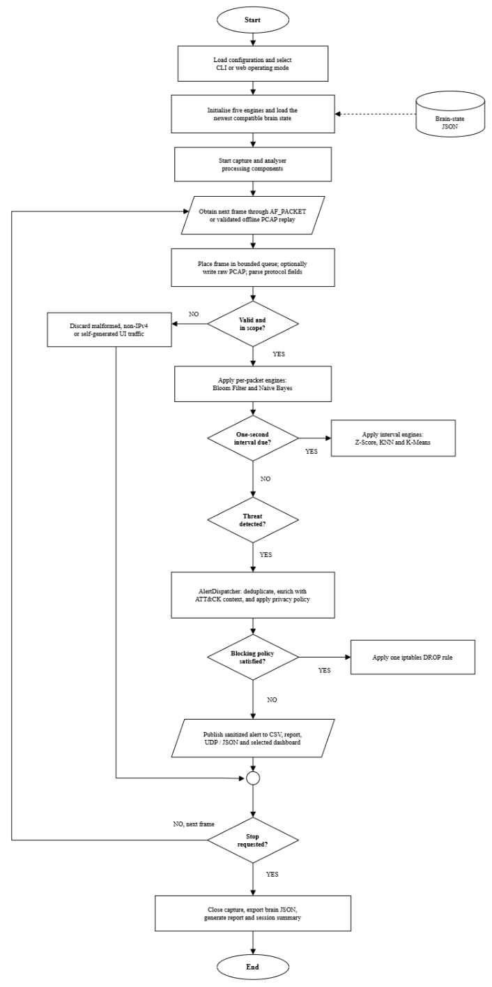
Figure 2.7: Current monitoring and manual response workflow
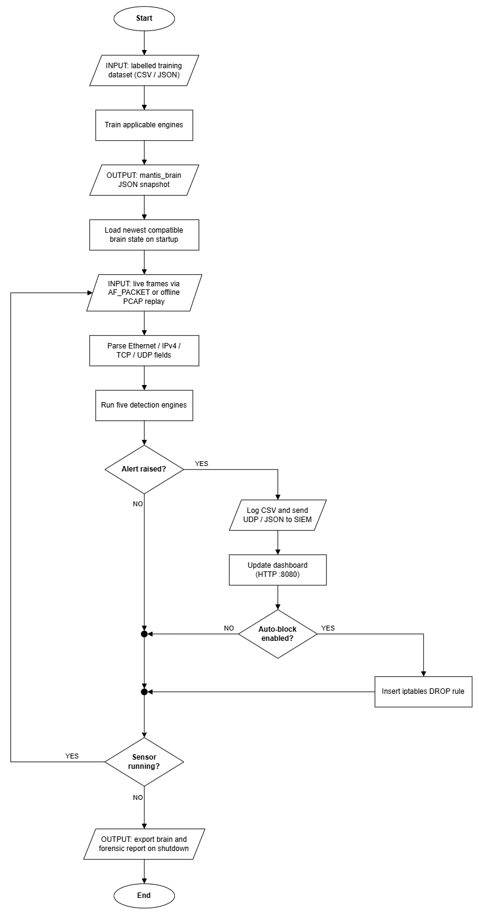
Figure 2.8: Proposed end to end MANTIS workflow
2.8.8 Performance and Environment Requirements
Live capture requires a Linux host that provides AF_PACKET and sufficient privilege or capability for raw sockets. The reference environment will record processor, memory, operating system version, Python version, interface, traffic source and test duration. The detection runtime uses the Python Standard Library; iptables and Linux capabilities are operating system facilities rather than Python package dependencies. Offline training, evaluation and PCAP replay can be exercised separately where live AF_PACKET capture is unavailable.

Table 2.7: Performance and environment targets for final evaluation
Requirement | Target | Verification method
Packet processing latency | p95 below 15 ms in the stated test environment | Timed replay and live loopback benchmark
Memory footprint | Sensor process below 100 MB resident memory | Repeated process sampling during controlled traffic
CPU utilisation | Below 25% of one reference vCPU at the stated load | Process monitoring with traffic rate recorded
Reliability | No crash or corrupted alert file during a 30 minute run | Sustained replay, shutdown and restart checks
Portability | Live capture on supported Linux; offline training and replay on other operating systems | Installation and smoke test matrix
Security | Active response disabled by default; captured payload minimised | Configuration review and negative tests
Table 2.7 defines evaluation targets, not completed results. The final discussion will report measured values with sample size, load and environment, and will identify any unmet target. This prevents interim observations or single loopback measurements from being presented as general performance claims.

2.9 Algorithms Implemented
The three algorithms below retain the interim report’s documentation pattern. Each is defined, expressed mathematically, described as a procedure, represented in pseudocode and linked to a flowchart. Mini-Batch K-Means and Bloom Filter are documented with the remaining system design material because their state update and persistence behaviour is closely connected to that chapter.

2.9.1 Z-Score Statistical Engine
The Z-Score engine monitors a packet rate observation x relative to an online estimate of the normal mean and standard deviation. It raises a volumetric anomaly indication when the absolute standardised deviation exceeds the configured threshold after sufficient baseline observations.

Mathematical Model
z = (x - mu) / sigma, alerting when |z| > 3. Mean mu and variance sigma are updated online via Welford's incremental method.
z = (X - μ) / σ

Step by Step Procedure
1. Read the current packets per second observation.
2. Update the running count, mean and second moment using Welford’s equations.
3. Derive the standard deviation when enough observations exist.
4. Calculate the absolute Z-Score and compare it with the configured threshold.
5. Return a normal or flood oriented verdict with the supporting score.

Pseudocode
INPUT current observation x and threshold τ
UPDATE n, mean μ and second moment M2
IF n < minimum_samples OR standard_deviation = 0: RETURN Normal
z = (x - μ) / standard_deviation
IF absolute(z) > τ: RETURN FloodAlert with score
RETURN Normal
Flowchart
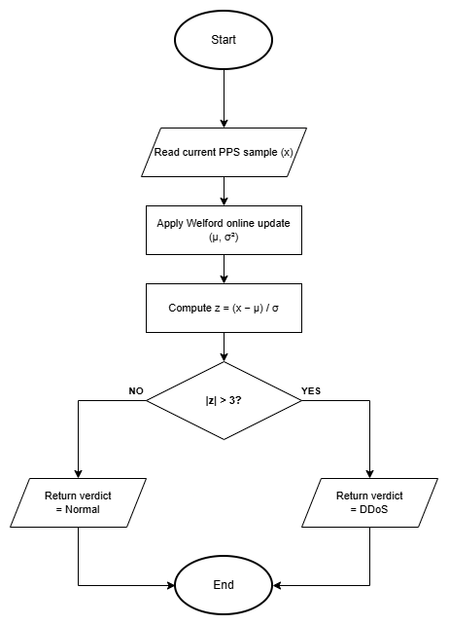
Figure 2.9: Z-Score statistical engine flowchart

2.9.2 K-Nearest Neighbours (KNN) Engine
The KNN engine is a supervised, instance based classifier used for scan oriented observations. A query vector is compared with labelled training vectors, and the majority label among the k closest neighbours determines the predicted class.
Mathematical Model
Euclidean distance d(p,q) = sqrt (sum_i (p_i q_i) ^2). Majority vote of K=3 nearest labelled neighbours assigns Normal vs Scan.

Step by Step Procedure
1. Construct the live feature vector, including the configured scan oriented counts.
2. Validate that a compatible labelled training set is available.
3. Calculate Euclidean distance to every stored training vector.
4. Select the k vectors with the smallest distances and count their labels.
5. Return the majority class with vote based confidence and distance evidence.

Pseudocode
INPUT query vector q and labelled training data D
distances = [(euclidean(q, vector), label) for each item in D]
neighbours = first k items after sorting distances
prediction = majority_label(neighbours)
confidence = votes_for_prediction / k
RETURN prediction, confidence and neighbour distance
Flowchart
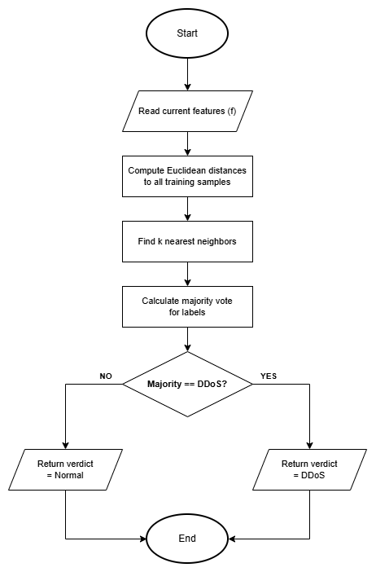
Figure 2.10: K-Nearest Neighbours engine flowchart

2.9.3 Multinomial Naive Bayes Engine
The Multinomial Naive Bayes engine classifies tokenised, unencrypted payload excerpts using class priors and token likelihoods learned from labelled examples. It is intentionally limited to visible payload text and cannot inspect encrypted application content.
Mathematical Model
log P(class|tokens) = log P(class) + sum_i log P(token_i|class); Laplace smoothing prevents zero counts on unseen tokens.

Step by Step Procedure
1. Decode the privacy limited payload excerpt and tokenise visible text.
2. Initialise each class score with its log prior probability.
3. Add the smoothed log likelihood of each token for each class.
4. Select the class with the largest score and derive confidence from the class scores.
5. Return a payload alert verdict only when the malicious class and threshold conditions are satisfied.

Pseudocode
INPUT payload bytes and trained class statistics
tokens = tokenise(decode(payload excerpt))
FOR each class c: score[c] = log_prior[c]
FOR each token w: score[c] += log(smoothed_probability(w, c))
prediction = class with maximum score
IF prediction is Malicious AND confidence >= threshold: RETURN PayloadAlert
RETURN Safe
Flowchart
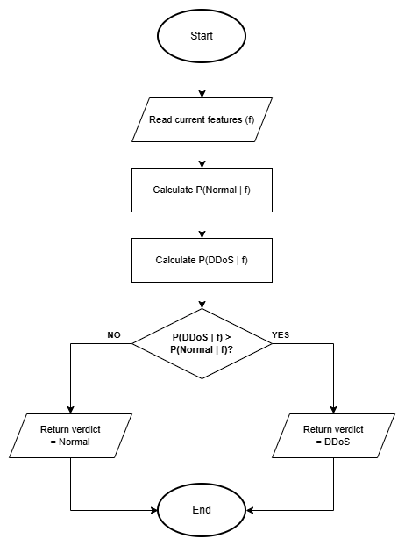
Figure 2.11: Multinomial Naive Bayes engine flowchart

3. System Analysis and Design
This chapter maps verified requirements to use cases, sequences, classes, activities, persistence and interface designs.

The design separates acquisition, parsing, detection, dispatch and presentation through a bounded queue and common Verdict.

3.1 Use Case
The Security Administrator starts monitoring, investigates alerts, manages learned state and exports evidence. The Host OS supplies frames and enforces approved rules, while an External SIEM receives telemetry. Figure 3.1a keeps these actors outside the MANTIS boundary.

Figure 3.1b uses include for mandatory capture and analysis, and extend for policy-enabled blocking, ensuring that an alert does not imply automatic response.

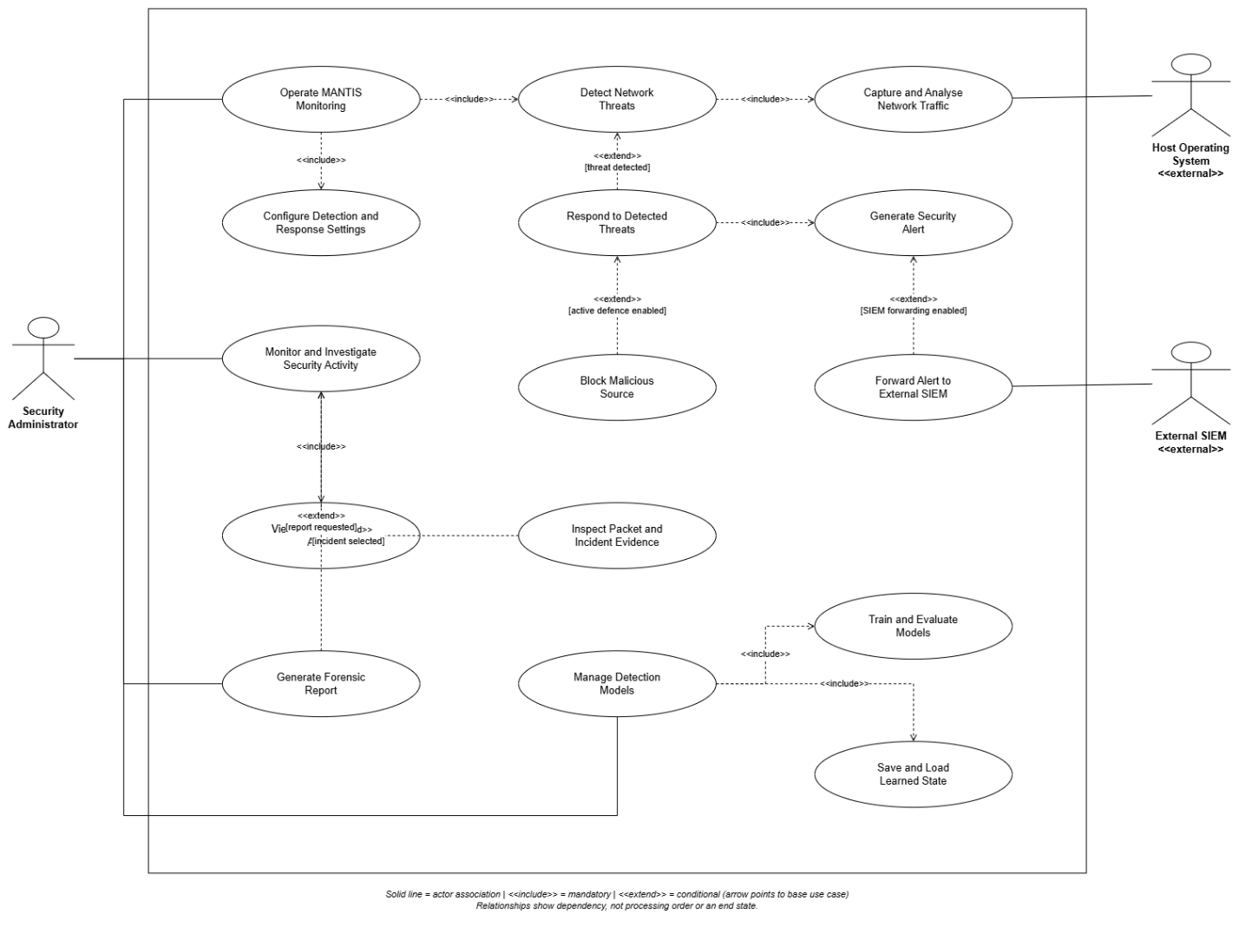
Figure 3.1b: MANTIS use case model
3.1.1 Use Case Documentation
Table 3.1 records associations, include and extend relationships; Table 3.2 documents preconditions, paths and exceptions.

Table 3.1: Actor use case associations, include and extend
Actor or included behaviour | Use case | Association | Meaning in MANTIS
Security Administrator | UC-01 Live monitoring | Association (primary) | Starts and stops the sensor; include Capture Traffic and Analyse Frames.
Security Administrator | UC-02 Investigate and export | Association (primary) | Uses the local dashboard and evidence export.
Security Administrator | UC-03 Train and restore models | Association (primary) | Runs train.py and supplies labelled CSV/JSON.
Security Administrator | UC-04 Apply active defence | Association (primary) | Enables --block; does not occur by default.
Host Operating System | UC-01 Live monitoring | Association | Supplies Ethernet frames via AF_PACKET and process privileges.
Host Operating System | UC-04 Apply active defence | Association | Enforces iptables DROP when the dispatcher requests it.
External SIEM / browser | Receive telemetry / view alerts | Association | UDP JSON to port 9999; HTTP GET on port 8080.
Capture Traffic | UC-01 | Include | Always executed during live or replay monitoring.
Analyse Frames | UC-01 | Include | Always executed after a supported frame is parsed.
Block Source | UC-01 | Extend | Occurs only when a threat verdict is raised and --block policy is satisfied.
The use cases match the implementation: the dashboard has no authentication and active defence is optional and policy-gated.

Table 3.2: Principal MANTIS use case documentation
ID and goal | Actor | Preconditions | Main success path | Alternative and postcondition
UC-01 Live monitoring | Security Administrator | Supported Linux host; sensor configured; raw capture permission for live mode. | Start sensor; capture frames; parse supported protocols; analyse relevant features; publish qualifying alerts. | Malformed frames are rejected without stopping the loop. Monitoring continues until a stop request; brain state and report are then written.
UC-02 Investigate and export | Security Administrator | Web SIEM running and packet or alert records available. | Open dashboard; filter packets or alerts; inspect source, engine, severity and ATT&CK context; request JSON or PCAP evidence. | An empty store returns a valid empty state. Exported records follow the configured privacy and snap length controls.
UC-03 Train and restore models | Security Administrator | Labelled CSV fields match the selected loader; output directory is writable. | Validate rows; train the selected engines; serialise a timestamped JSON brain; import the latest compatible sections on start up. | Missing columns raise a dataset error. Missing or incompatible sections retain safe seeded state rather than corrupting the engine.
UC-04 Apply active defence | Security Administrator and Host OS | A threat identifies a source; blocking is explicitly enabled; kind is permitted; source is not whitelisted. | Dispatcher evaluates policy; ActiveDefense inserts one iptables DROP rule; response status and rule are recorded. | Disabled policy, failed command, duplicate source or whitelist match produces no block. MANTIS rules are removable during shutdown.

3.2 Sequence Diagrams
Live detection moves frames from the kernel through the bounded queue and parser to compatible engines. AlertDispatcher then handles evidence, telemetry, dashboard publication and optional response.

Policy and whitelist checks precede response; brain export occurs at shutdown, and privacy processing precedes persistence.
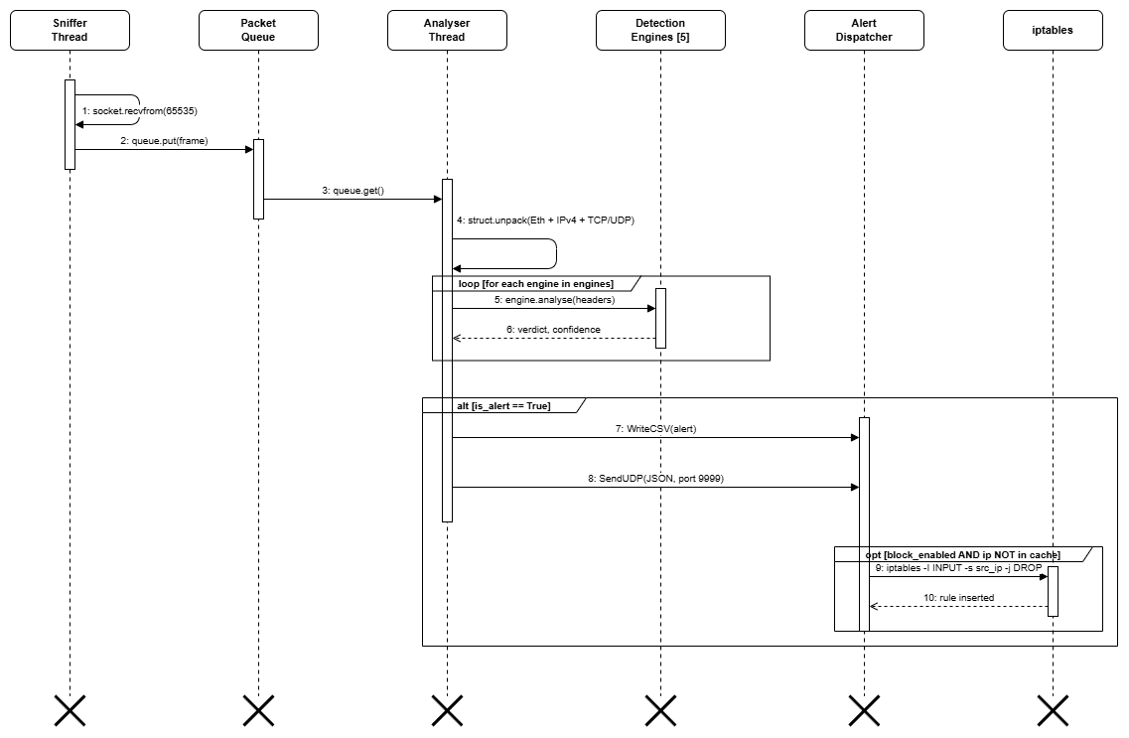
Figure 3.2a: Live detection sequence from captured frame to operator visible alert
Training validates labelled CSV data, fits applicable engines and writes the resulting brain state as JSON.
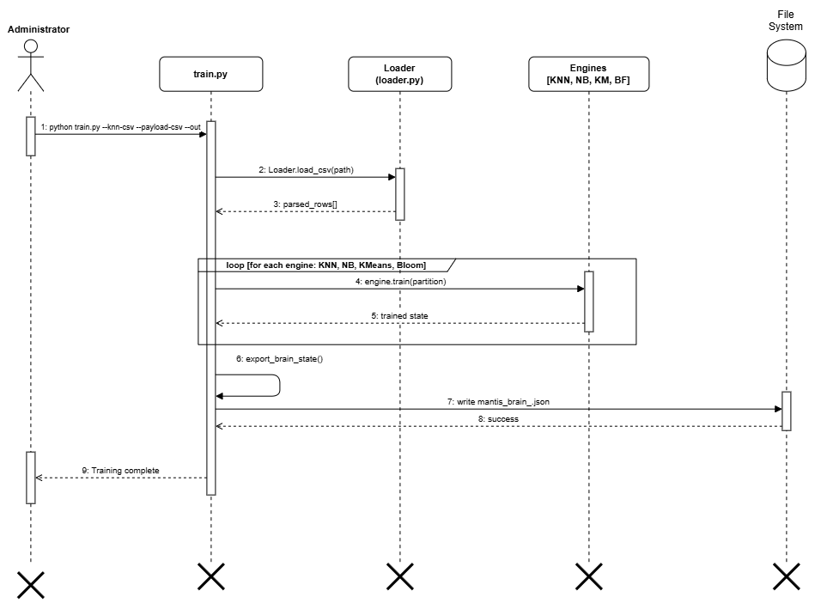
Figure 3.2b: Training pipeline from validated data to persistent engine state
AlertDispatcher sends JSON to UDP 9999; the listener updates a bounded buffer served to the browser over HTTP.
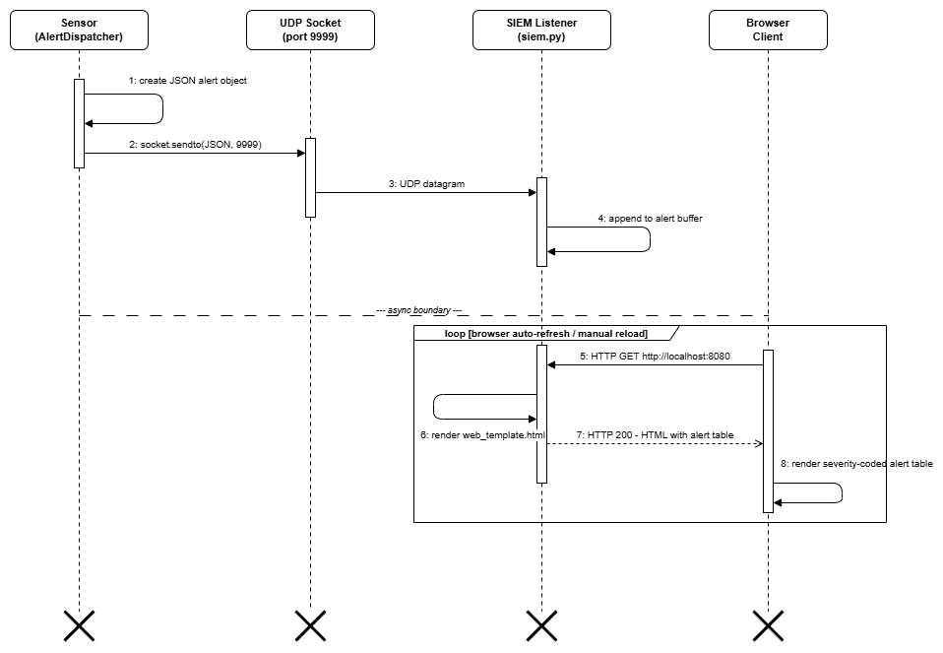
Figure 3.2c: SIEM alert delivery and browser dashboard retrieval
Offline PCAP replay uses the same parser and engines without privileged live capture.
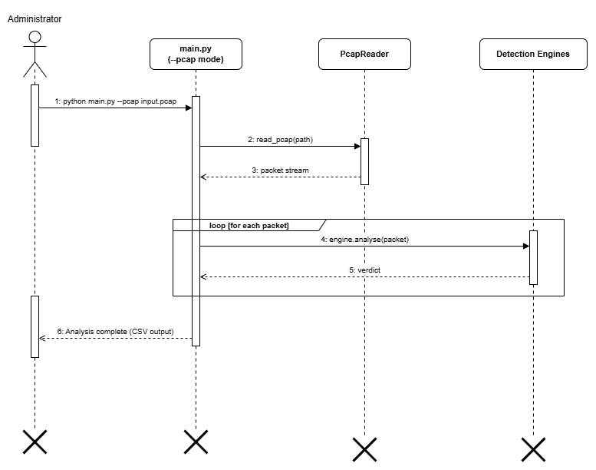
Figure 3.2d: Offline PCAP replay and finite analysis completion

3.3 Class Diagram
One SensorNode composes one or more DetectionEngine objects, one PacketParser and one AlertDispatcher. AlertDispatcher may invoke zero or one ActiveDefense. Inheritance arrows have no multiplicities.

SensorNode owns capture and components; DetectionEngine defines common operations, and Verdict gives the dispatcher a consistent label, confidence, rationale and threat flag.

Composition marks SensorNode-owned lifecycles, while ActiveDefense remains optional. The notation matches sensor.py and AlertDispatcher construction.
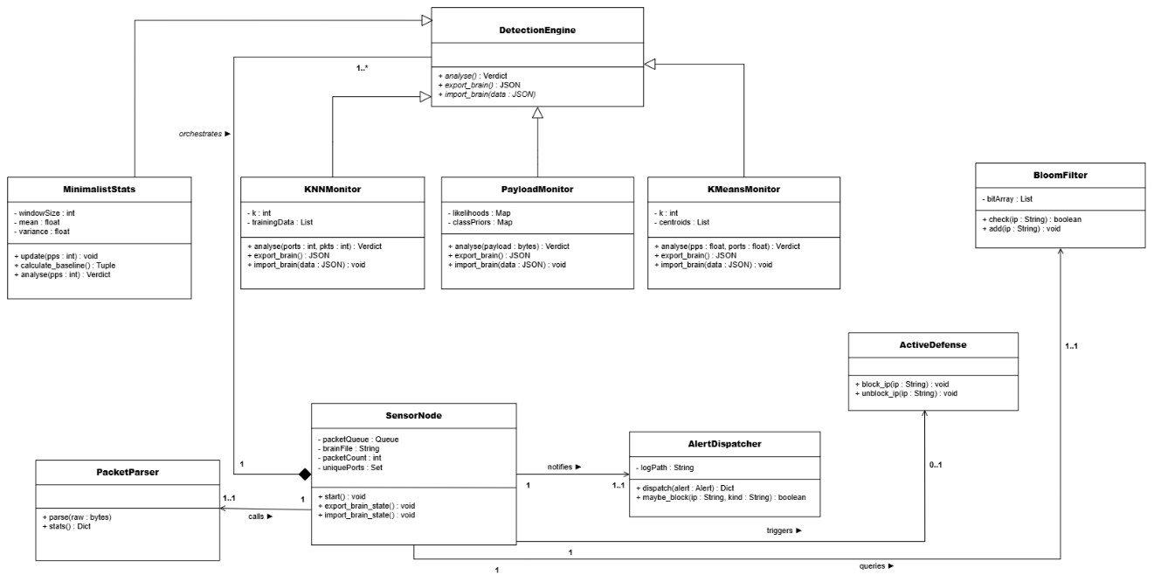
Figure 3.3: Corrected MANTIS class model with inheritance, composition and explicit UML multiplicities

3.4 Activity Diagrams
Captured frames pass through the queue, parser and engines before evidence, telemetry and optional policy-controlled response.
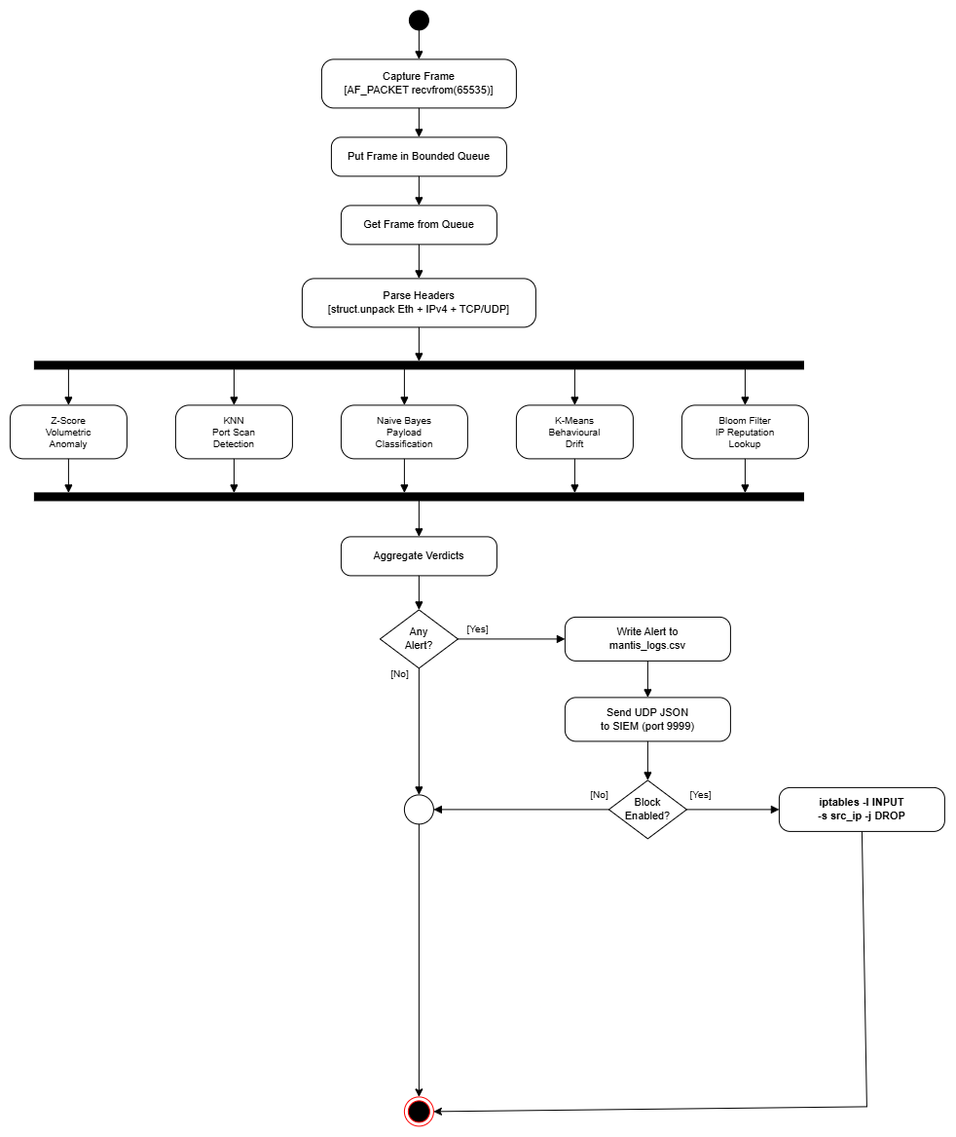
Figure 3.4a: Live detection, verdict aggregation and optional response activity
Training validates data, fits applicable engines, seeds reputation indicators and exports one JSON brain.
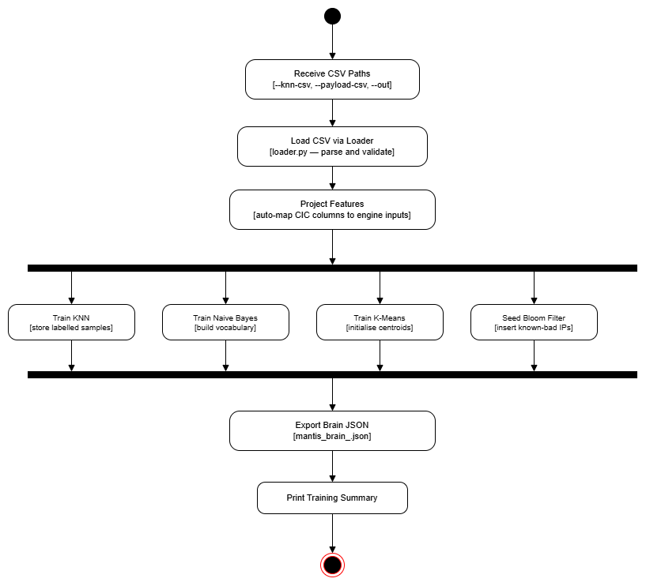
Figure 3.4b: Training pipeline from input validation to brain export
Evaluation classifies labelled samples, updates confusion counts and calculates the reported metrics.
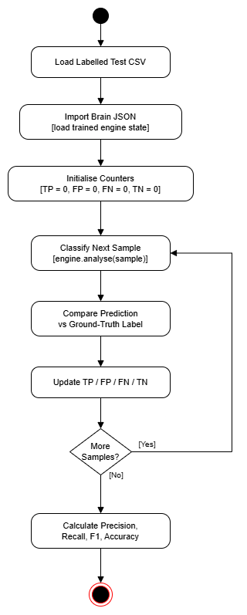
Figure 3.4c: Evaluation harness and confusion matrix metric activity
Brain persistence starts with engine initialisation and locating the latest JSON state. Compatible import and safe defaults converge before monitoring begins.

Shutdown closes threads and PCAP output, exports engine state and generates the report, matching the implemented SensorNode lifecycle.
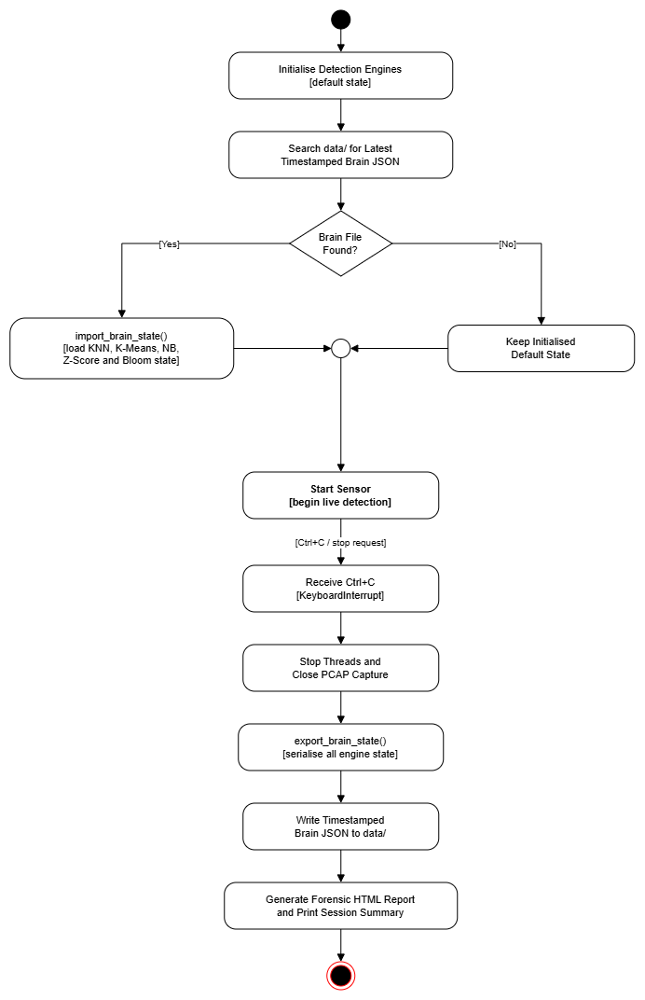
Figure 3.4d: Brain persistence and orderly shutdown activity flow
Installation selects a supported Linux package manager, installs firewall support, grants capture capability and creates the command entry point.
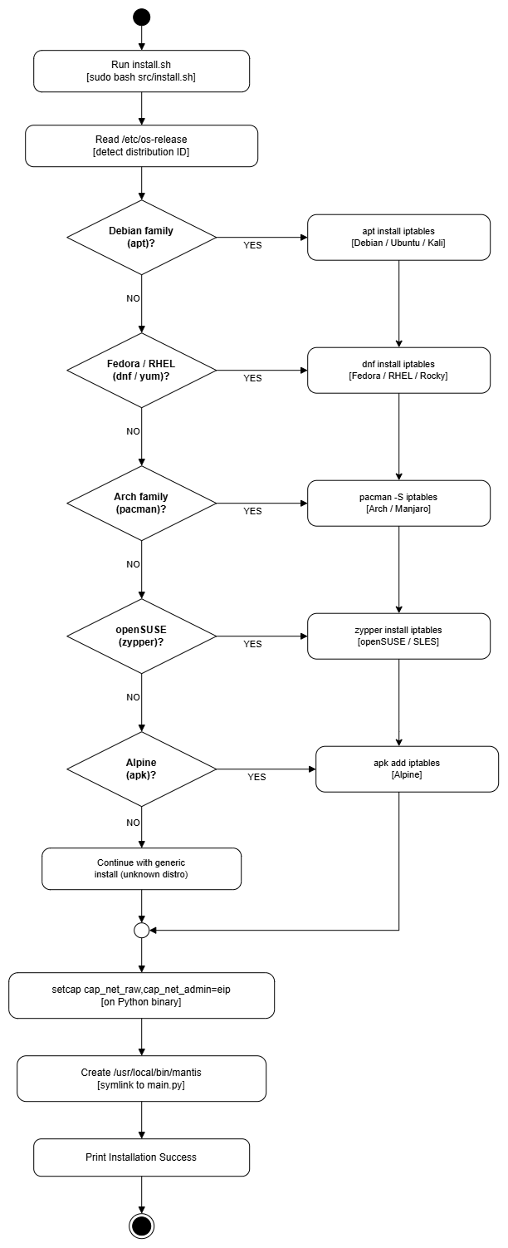
Figure 3.4e: Linux installation activity with if-else-if package manager decisions

3.5 Database Schema
MANTIS uses bounded memory and inspectable flat files rather than a relational database. Packet events produce verdicts and alerts, while firewall rules require policy approval; shared fields preserve traceability.

Redacted alerts use CSV, telemetry and engine state use JSON, evidence uses PCAP, and findings use HTML. The bounded packet store improves portability but lacks database transactions and long-term retention.

Table 3.3: Logical to physical persistence mapping
Logical record | Physical representation | Principal fields | Purpose
Packet event | In memory PacketStore; optional PCAP | Timestamp, addressing, protocol, ports, length, frame excerpt | Bounded investigation and replay evidence
Threat alert | CSV and UDP/JSON | Engine, message, confidence, MITRE fields, severity, risk, sanitised excerpt | Audit trail and real time SIEM ingestion
Brain snapshot | mantis_brain_*.json | KNN samples, K-Means centroids, NB likelihoods, Z-Score statistics, Bloom bits | Readable restart and training state
Firewall response | Runtime iptables rule and dispatcher summary | Source, policy category, applied status | Opt in and reversible local containment
Forensic report | HTML | Session summary and alert chronology | Human readable hand off evidence

3.6 Algorithms Implemented
Chapter 2 introduced the algorithms; this section completes the state-update and persistence design for K-Means and Bloom Filter.
3.6.1 Online Mini-Batch K-Means Engine
KMeansMonitor assigns rate and port observations to the nearest centroid. Distance beyond the novelty threshold is anomalous; normal observations update the centroid incrementally without retaining the full stream.

Mathematical Model
For nearest centroid c_k: c_k := c_k + alpha * (x - c_k) with learning rate alpha, following the mini batch update of Sculley (2010).

Step by Step Procedure
- Compute distance from point x to each centroid.
- Assign x to argmin centroid index.
- Update centroid with learning rate alpha.
- Flag alert if distance exceeds configured threshold.

Pseudocode
Mini-Batch K-Means classify (x = [pps, unique_ports]):
nearest_k = argmin (euclidean (x, c) FOR c IN centroids)
min_dist = euclidean (x, centroids[nearest_k])
centroids[nearest_k] += alpha * (x centroids[nearest_k]) // Sculley 2010
IF min_dist > threshold: RETURN BehaviouralDrift
ELSE: RETURN Normal
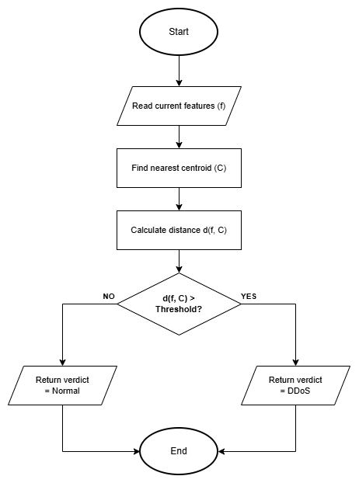
Figure 3.5: Online Mini-Batch K-Means flow from explicit feature input to normal or anomaly output

3.6.2 Bloom Filter Reputation Engine
BloomFilter hashes known harmful indicators into a bit array. Missing bits prove non-membership, while all-set bits indicate probable membership in O(k) lookup time.

Mathematical Model
m bits and k hash functions give an expected false positive rate of (1 - exp(-kn/m))^k for n inserted items (Mitzenmacher and Upfal, 2017).

Step by Step Procedure
- Hash item with k independent hash functions.
- Add all k bit positions to 1.
- On check: return true only if all k positions are 1.

Pseudocode
Bloom Filter check(ip):
FOR seed IN hash_seeds:
pos = adler32(encode (ip + str(seed))) mod m
IF bit_array[pos] == 0: RETURN Clean // Definite non member
// All k bits set -> probable member
fp_rate = (1 - exp(-k*n/m))^k // Mitzenmacher & Upfal 2017
RETURN KnownMalicious, confidence = 1.0 fp_rate
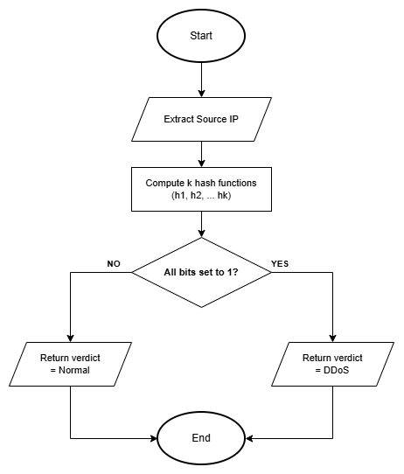
Figure 3.6: Bloom Filter reputation membership decision flow

3.7 System Interface and Design
The terminal supports headless use; the console shows health, packets, alerts and configuration through local UDP and HTTP services.

The interface exposes event evidence, engine, severity, ATT&CK context, defence state and privacy state.

3.7.1 Wireframe
Wireframes establish the shared header and hierarchy for health, packets, alerts and architecture before styling.

Overview page

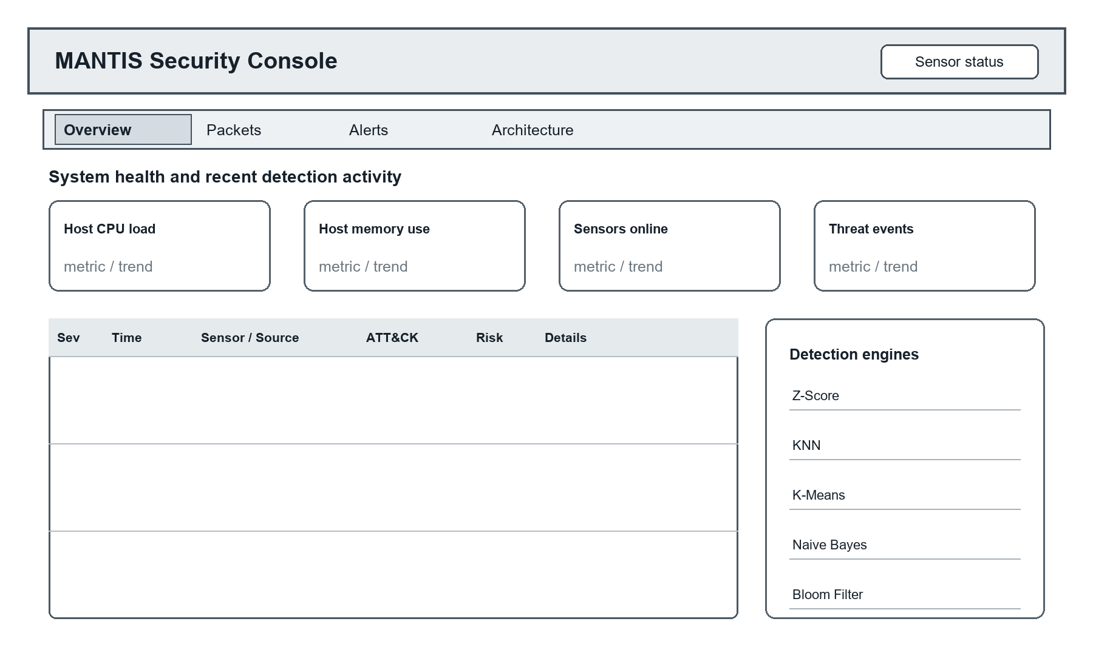
Figure 3.7a: Overview page wireframe showing system health, recent events and engine activity
Packets page

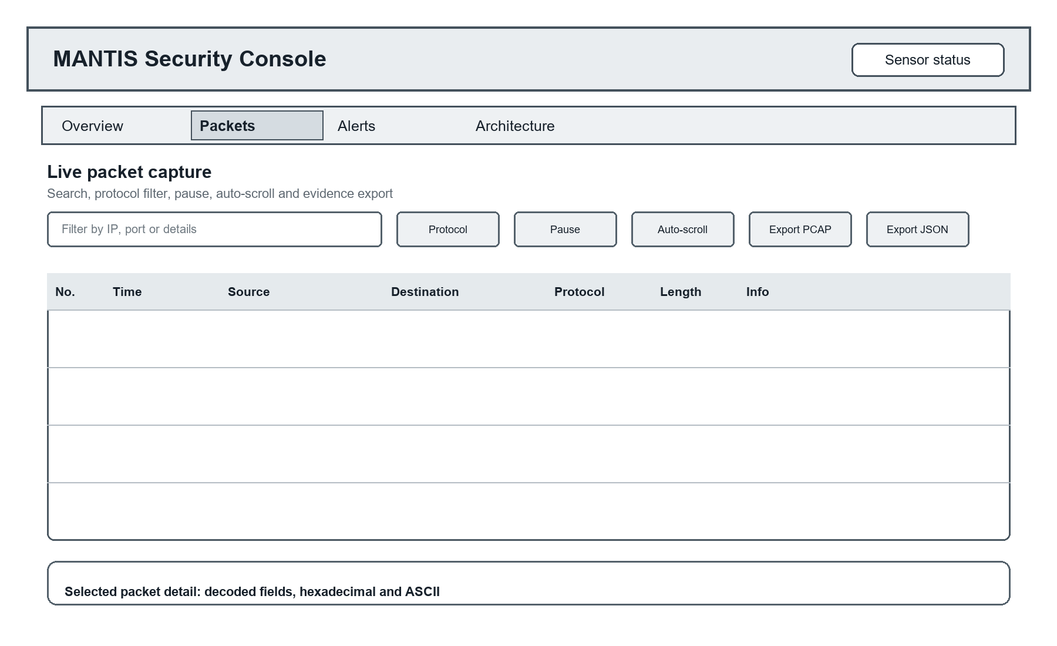
Figure 3.7b: Packets page wireframe showing capture controls, packet history and selected frame detail
Alerts page

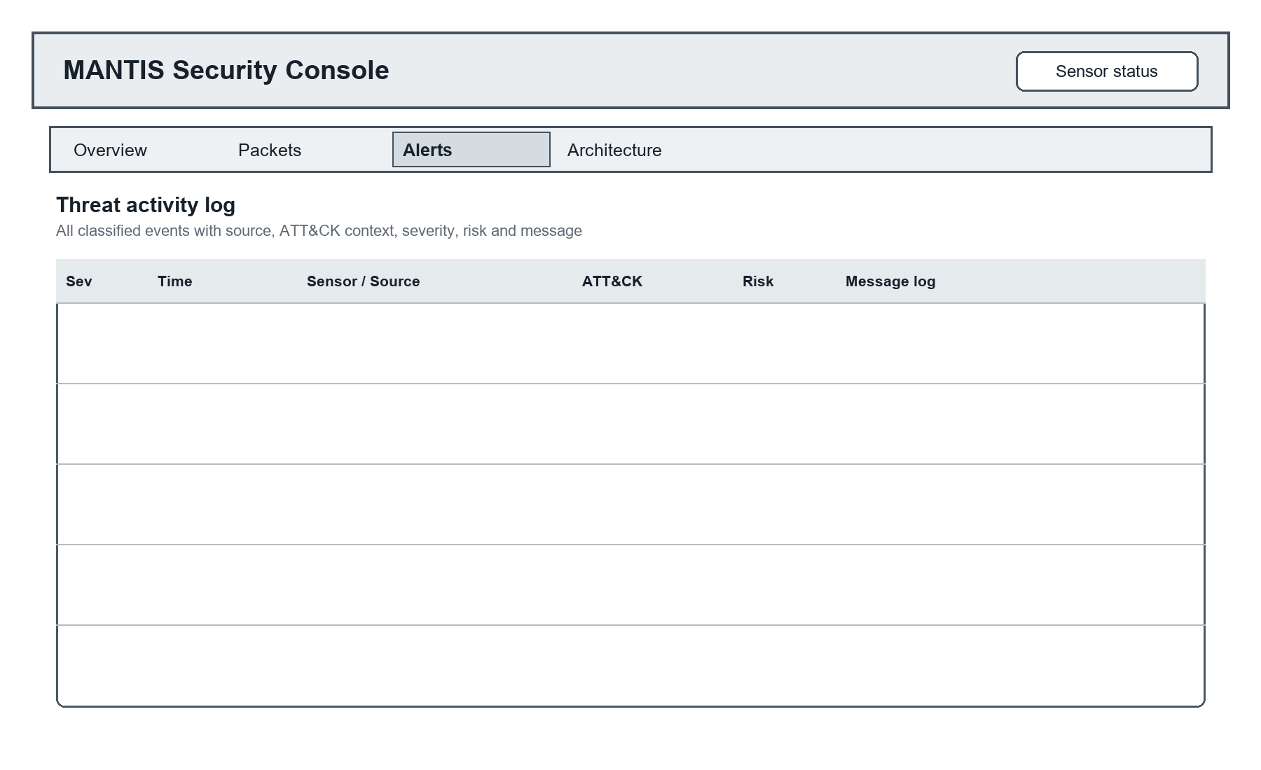
Figure 3.7c: Alerts page wireframe showing the complete bounded threat activity log
Architecture page

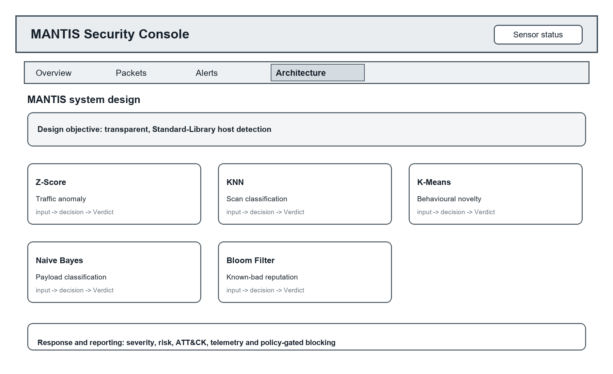
Figure 3.7d: Architecture page wireframe showing all five engines and the response path

3.7.2 Mockup
Mockups apply the implemented console style and API contract to controlled demonstration data.
Overview page

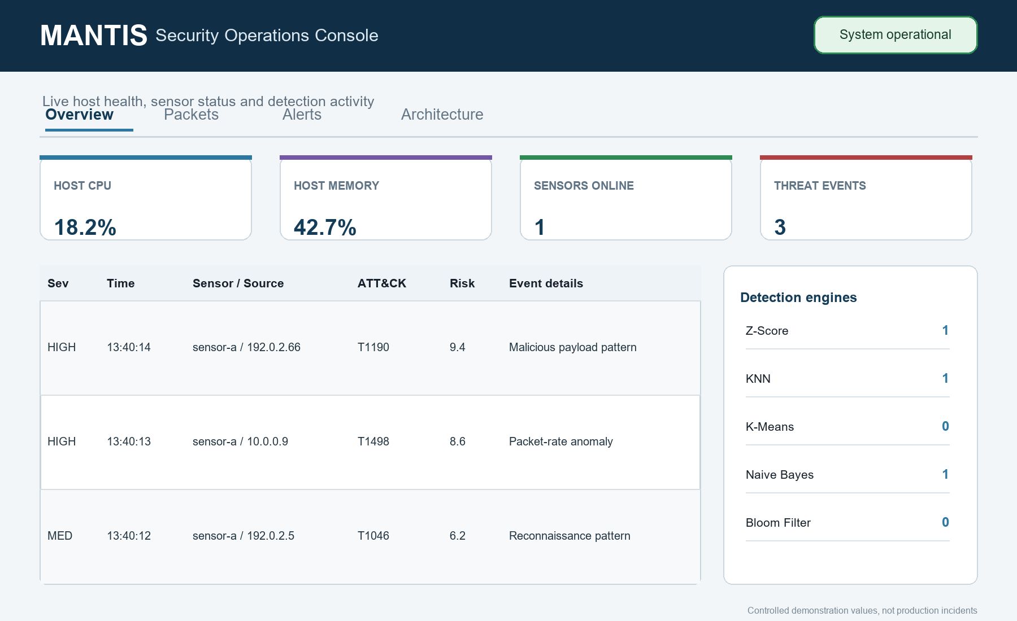
Figure 3.8a: Overview page mockup with controlled health metrics, recent events and five engine activity

Packets page

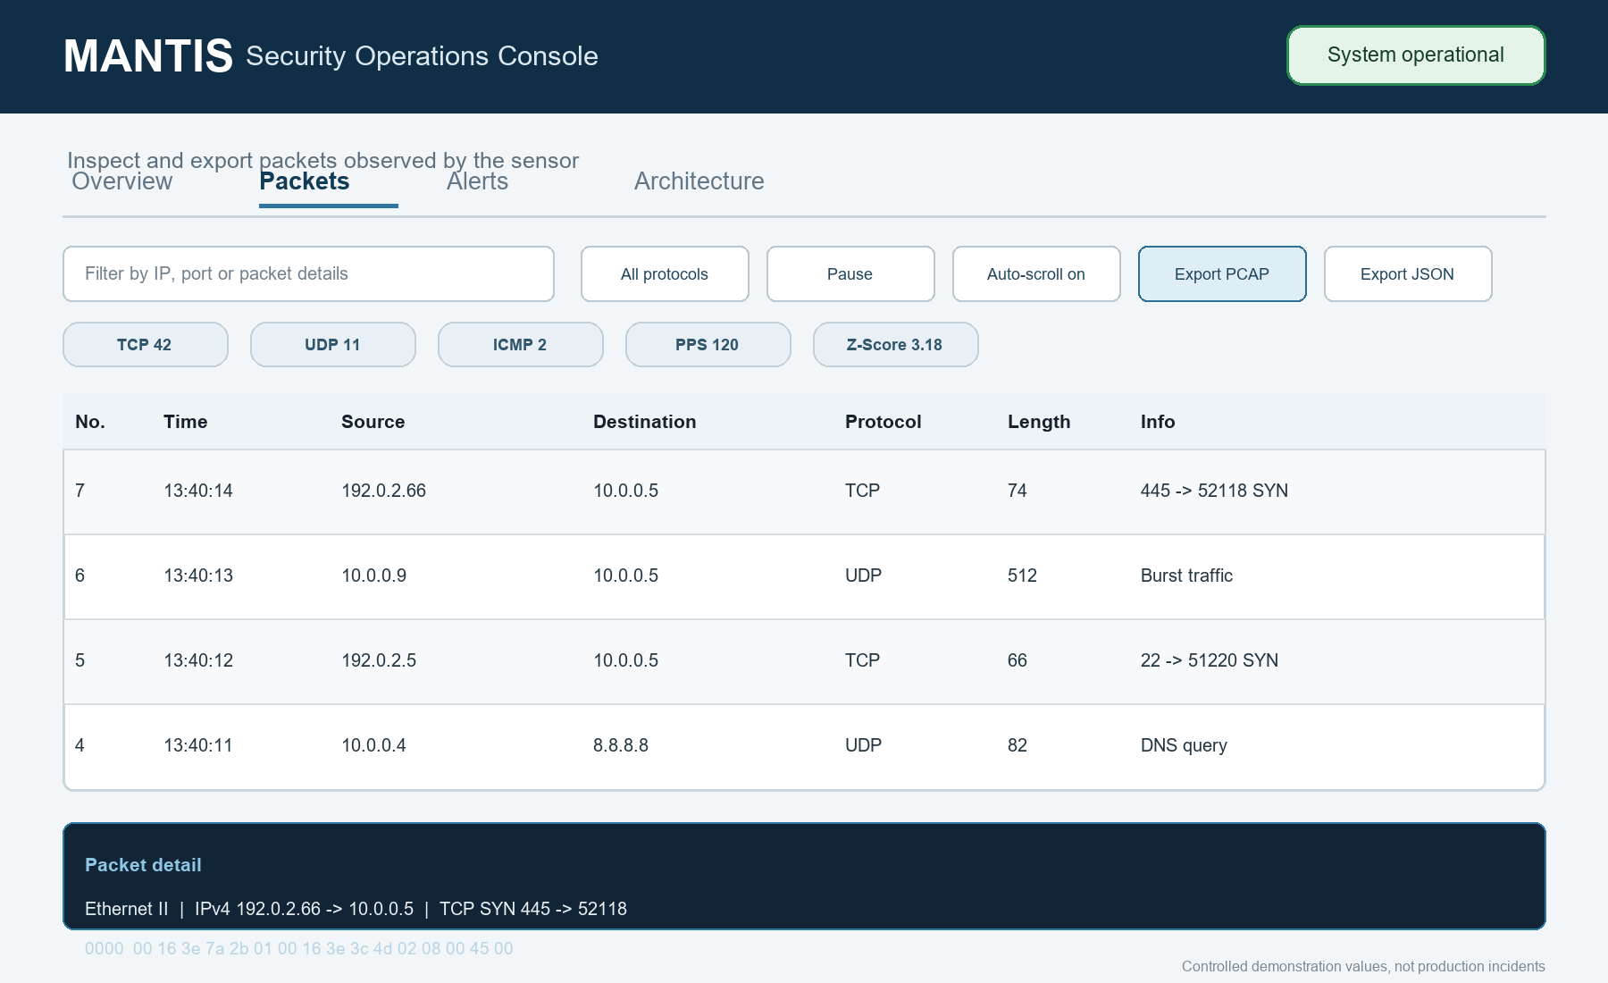
Figure 3.8b: Packets page mockup with filters, protocol counters, exports and packet detail

Alerts page

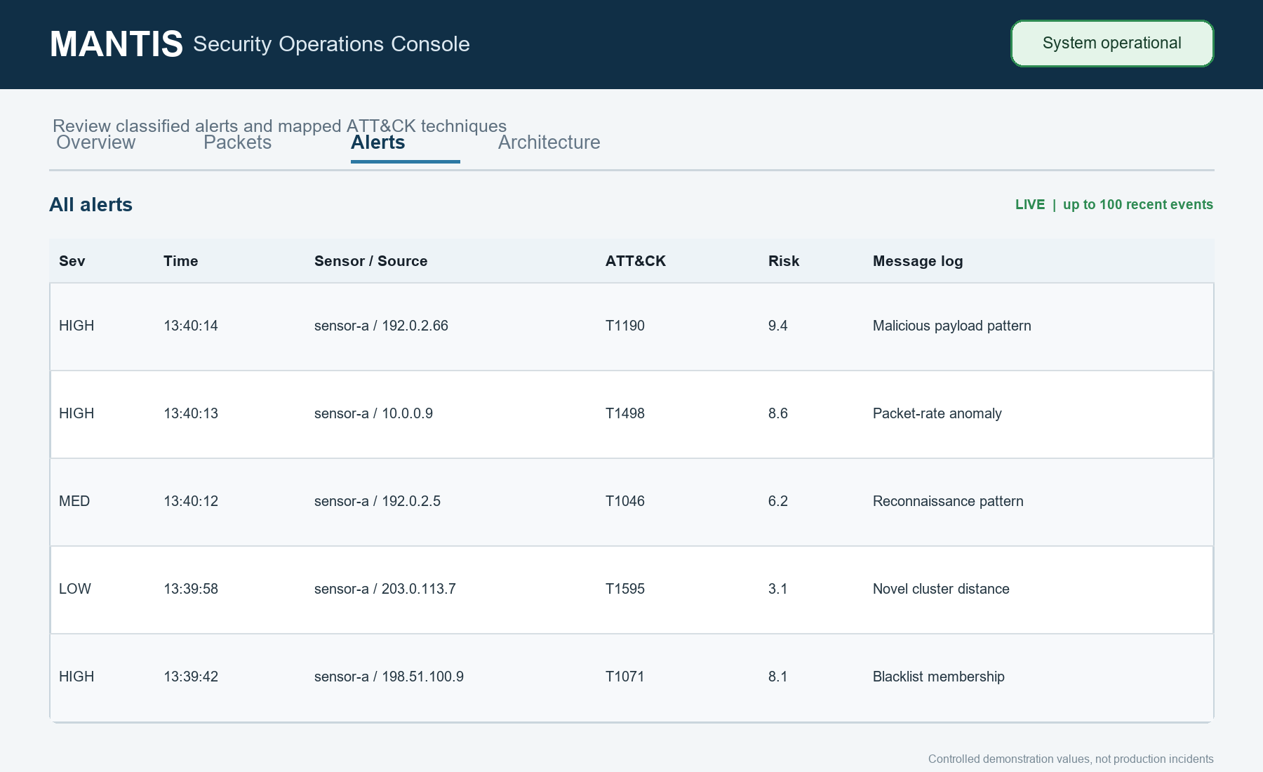
Figure 3.8c: Alerts page mockup with the complete in memory threat log and ATT&CK context

Architecture page

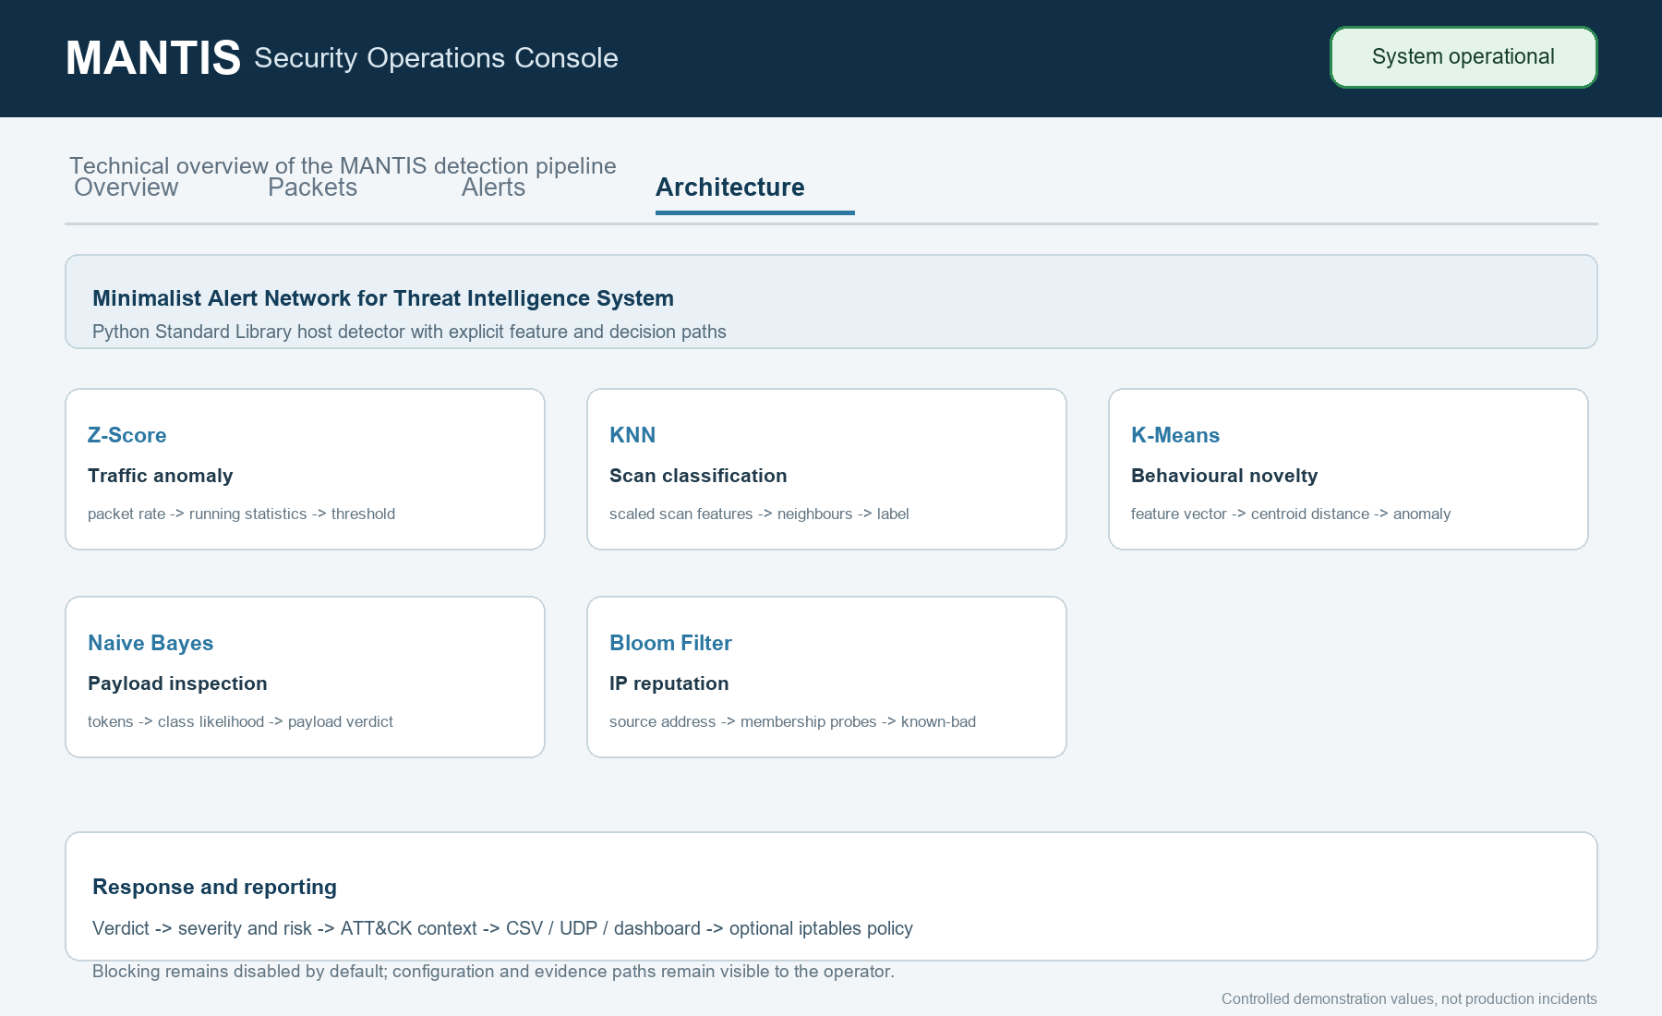
Figure 3.8d: Architecture page mockup documenting all five engines and policy gated response
The console supports filtering, packet detail, policy reporting and bounded export; authentication, TLS and case management remain outside scope.

4. System Build and Technical Notes
main.py merges configuration, verifies Linux capture capability, starts the optional SIEM and launches SensorNode capture and analysis. Offline PCAP replay uses the same parser and engines.

Packet Capture and Analysis Build
SensorNode queues AF_PACKET frames and PacketParser safely validates supported Ethernet, VLAN, IPv4, TCP, UDP and ICMP structures. Compatible statistics, payloads and addresses then reach the appropriate engines.

Detection, Dispatch and Response Build
Each engine returns a common Verdict. AlertDispatcher adds ATT&CK context, persists and publishes qualifying alerts, then permits an iptables rule only when category, whitelist and duplicate checks pass.

Training, State and Evidence Build
Dataset loaders validate engine-specific columns, training writes readable brain state, and SensorNode restores compatible sections. Redaction precedes CSV, JSON, PCAP or report output.
Technical Constraints
Linux privileges are required for capture and response. Encrypted payloads remain opaque, UDP is best-effort, storage is bounded, and the embedded HTTP service is limited to controlled local deployment.

Table 4.1: MANTIS build components and technical constraints
Build area | Principal modules | Implemented responsibility | Technical note
Entry and configuration | main.py, config.py | Argument parsing, precedence, safe defaults, privilege check | No third party runtime package
Acquisition and parsing | sensor.py, parser.py | AF_PACKET producer, bounded queue, protocol decoding | Live capture is Linux specific
Detection | engines/*.py | Five engines under DetectionEngine and Verdict | State exported through a uniform JSON contract
Dispatch and response | dispatcher.py, active_defense.py | Audit, telemetry, UI publication and policy gated iptables | Blocking is off by default
Presentation and evidence | siem.py, web_template.html, pcap.py, reporting.py | HTTP/UDP console, packet export and HTML report | HTTP 8080 and UDP 9999 by default
Training and evaluation | training/*, evaluation/*, replay.py | Validated loaders, model training, metrics and deterministic replay | External datasets must match engine semantics

5. Testing Strategy and Evaluation
Testing verifies specified behaviour; evaluation judges whether evidence supports the claims. Component, integration and system results remain separate from detection-effectiveness metrics.

On 20 August 2026, unittest discovery passed all 116 tests in 4.642 seconds. UDP ResourceWarnings remain a harness clean-up item, and no unmeasured CPU, memory or latency claim is made.

5.1 Testing Definitions and Approach
Unit tests isolate rules, integration tests cross modules, system tests use loopback services, and regression tests preserve fixes. Table 5.1 maps levels to requirements and executed modules.

Table 5.1: Test levels mapped to requirements and evidence modules
Test level | FR / NFR traced | What is exercised | Evidence module
Unit | FR4, FR12, NFR2, NFR8 | Engine mathematics, config, privacy, PCAP helpers | test_engines.py, test_modules.py
Integration | FR1–FR8, FR10, FR14–FR22, NFR3, NFR4 | Parser→engines, dispatcher, brain, replay, packet store | test_integration.py
System | FR5, FR9, FR18, NFR7 | Real UDP listener and HTTP SIEM on loopback | test_siem_api.py
Regression | FR4, NFR2 | Flood not scan, baseline poisoning, stealth scan, K-Means non poisoning | test_modules.py / test_engines.py
Training | FR5, FR6, FR12 | Column validation and brain serialisation | test_training_and_eval.py

Positive, negative, boundary and failure cases verify detection, benign handling, parser safety, privacy and policy-gated response. Synthetic frames and PCAP replay avoid attacking external systems.

5.2 Algorithm Tests
Engine tests check both detection and non detection behaviour. Z-Score verifies warm up, Welford stability, sustained flood detection and baseline poisoning protection. KNN verifies scaled features, normal browsing, flood versus scan separation and low volume scans. K-Means verifies warm up, familiar traffic, novelty distance and withholding anomalous updates. Naive Bayes tests benign payloads, malicious tokens and the single token ADMIN safeguard. Bloom tests feed loading, membership, saturation and the no false negative property for inserted indicators.
Constructed samples first verified each engine's intended rule. KNN, Z-Score, K-Means and Bloom produced 1.0000 scores on only 25 to 44 co-authored records, while Naive Bayes produced F1 0.9565 and MCC 0.9199 on 24 records. These matched checks verify code paths but are not independent field-accuracy evidence. Table 5.2 therefore reports the larger external stress test instead.

Table 5.2: External CIC-IoT2023 Z-Score stress-test results
Evaluation scope | Rows | Precision | Recall | F1 | MCC
All 63 merged CSV files | 45,018,252 | 0.997417 | 0.043619 | 0.083582 | 0.029049
BENIGN and DoS/DDoS | 41,333,350 | 0.997302 | 0.045574 | 0.087165 | 0.031179
All 45,018,252 rows (9.30 GB) from 63 extracted Merged CSV files were streamed once, resetting the detector for each separate non-temporal export. Results were TP 1,917,787, FP 4,967, FN 42,049,152 and TN 1,046,346. Precision 0.997417 concealed recall 0.043619: 95.64 percent of attack rows were missed. F1 0.083582, balanced accuracy 0.519447 and MCC 0.029049 were near chance. Because prevalence was 0.976647, an always-positive baseline reached F1 0.988186. The BENIGN plus DoS/DDoS subset was similar. Only Rate is compatible across the files; unique_ports, payload, source IP and reputation labels are absent. This is therefore a Z-Score transfer stress test, not a five-engine benchmark.

5.3 Test Cases and Scenarios
The selected cases below trace the main functional and safety requirements to observable outcomes. The generated replay contains a benign warm up followed by port scan, flood, malicious payload and known bad source phases. System tests use loopback services and controlled datagrams, while firewall tests substitute a recording defence object so the suite never modifies the host firewall.

Table 5.3 lists expected against actual outcomes: every listed case passed in the 20 August 2026 run (116 tests, 4.642 s, unittest discovery), and the actual results matched the expected column. Each case was then re executed in isolation on the same day and the terminal output was captured; this evidence is reproduced case by case in Table 5.4. The results verify the implementation and do not certify production accuracy on unseen operational traffic.

Table 5.3: Twenty eight representative executed test cases and scenarios
ID | Level | Scenario | Expected outcome | Status
TC-01 | Unit | Benign payload | Return Safe with no threat | ☑
TC-02 | Unit | UNION SELECT payload | Flag malicious keywords | ☑
TC-03 | Regression | High volume on one port | Classified Normal, not Scan | ☑
TC-04 | Regression | Sustained flood after Z-Score warm up | Repeated alerts without baseline poisoning | ☑
TC-05 | Unit | Known and unknown indicators | Known found; unknown clean | ☑
TC-06 | Integration | Malformed and truncated frames | Reject safely; analyser remains available | ☑
TC-07 | Integration | Credential and email in alert | Sensitive values absent | ☑
TC-08 | Integration | Response policy combinations | Only approved case blocks | ☑
TC-09 | System | SIEM UDP and HTTP API | Return technique, severity and risk | ☑
TC-10 | System | Buffered frame PCAP export | PCAP reopens and decodes | ☑
TC-11 | Replay | 13,159 frame five phase replay | Correct engines fire by phase | ☑
TC-12 | Persistence | Five-engine state round trip | Restored state matches | ☑
TC-13 | Unit | K-Means warm up | No alert before warm-up | ☑
TC-14 | Regression | K-Means anomalous observation | Flag novelty without centroid poisoning | ☑
TC-15 | Regression | Low volume stealth scan | Detect scaled stealth scan | ☑
TC-16 | Unit | Invalid configuration value | Ignore invalid override safely | ☑
TC-17 | Unit | Threat intelligence feed | Strip comments; retain inserted indicators | ☑
TC-18 | Integration | VLAN and ICMP frames | Decode supported frames | ☑
TC-19 | Integration | Packet store capacity | Rotate entries within capacity | ☑
TC-20 | Integration | Duplicate alert dispatch | Publish equivalent alert once | ☑
TC-21 | Integration | Duplicate active response request | Record one firewall rule | ☑
TC-22 | Integration | Distributed high rate traffic | Do not attribute one source | ☑
TC-23 | Unit | ATT&CK and risk mapping | Map technique and bounded risk | ☑
TC-24 | Unit | Payload privacy limits | Remove controls; cap at 64 bytes | ☑
TC-25 | Unit | PCAP endian, time and snap length | Preserve capture semantics | ☑
TC-26 | System | Malformed SIEM datagram | Reject input and remain available | ☑
TC-27 | System | Statistics and filtering | Report live and filtered values | ☑
TC-28 | Training | Dataset missing required columns | Raise clear schema error | ☑
Table 5.4 reproduces the white terminal execution evidence for every case in Table 5.3. Each screenshot shows the exact unittest command, the engine or pipeline output produced during the run and the final OK verdict, captured on 20 August 2026.

Table 5.4: Terminal execution evidence for test cases TC-01 to TC-28
ID | Executed test evidence (white terminal)
TC-01 | 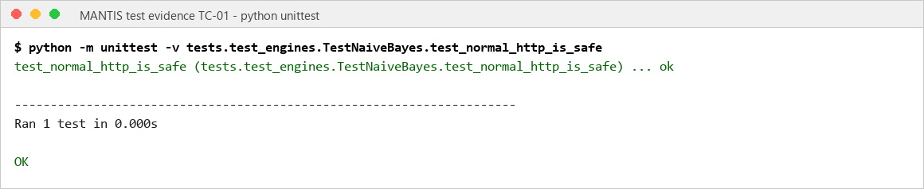
TC-02 | 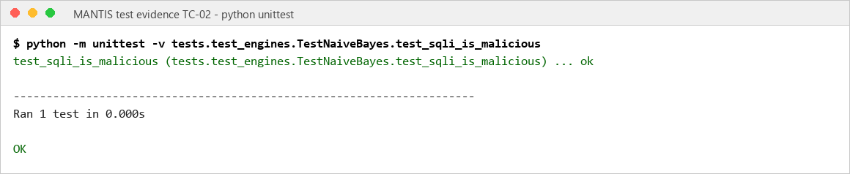
TC-03 | 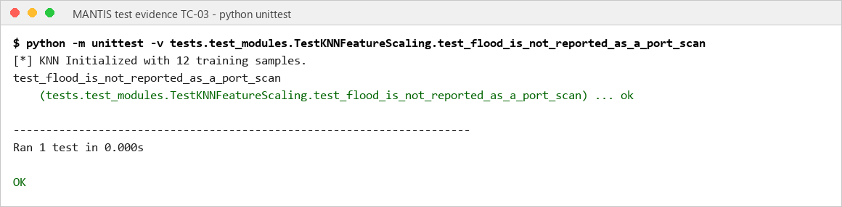
TC-04 | 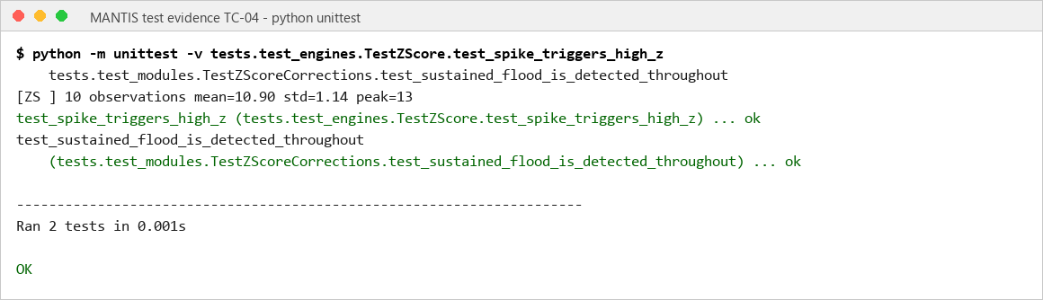
TC-05 | 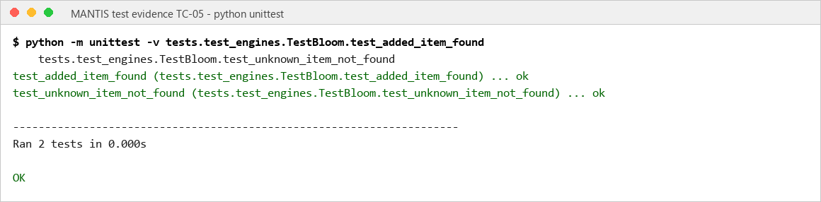
TC-06 | 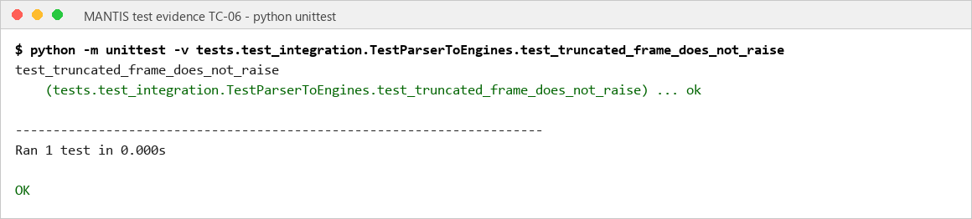
TC-07 | 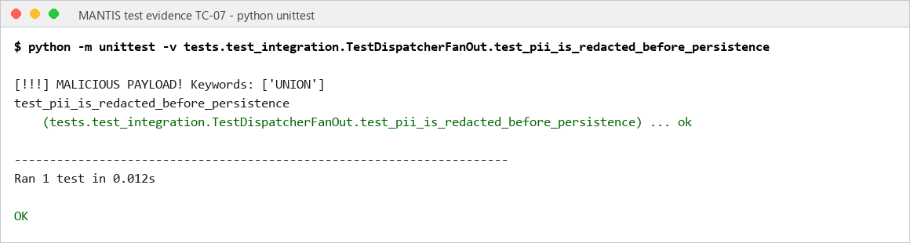
TC-08 | 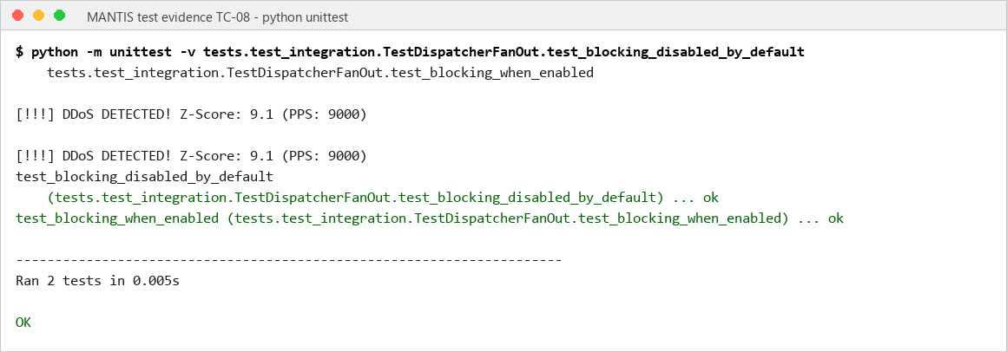
TC-09 | 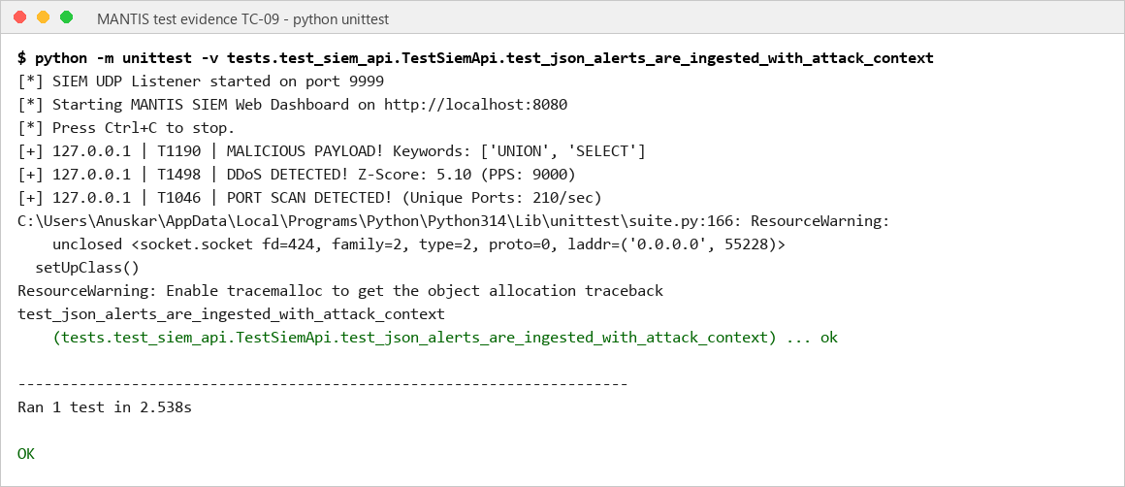
TC-10 | 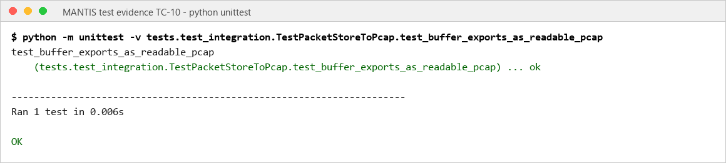
TC-11 | 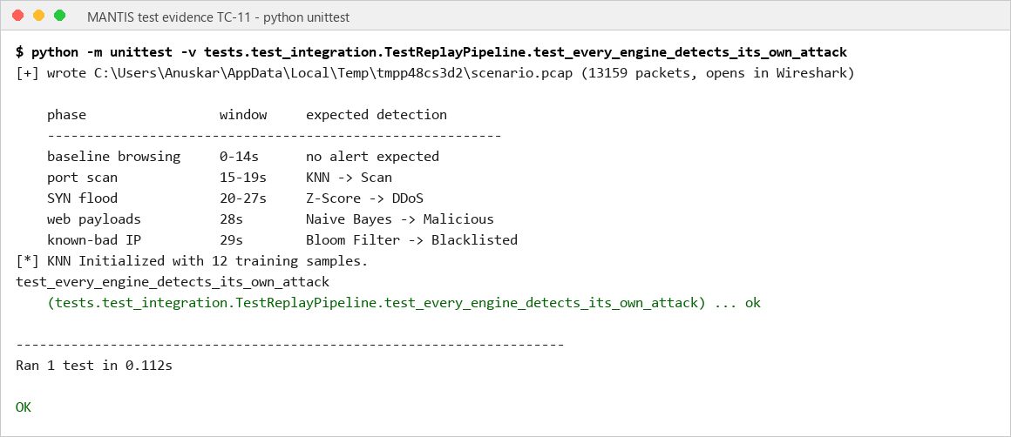
TC-12 | 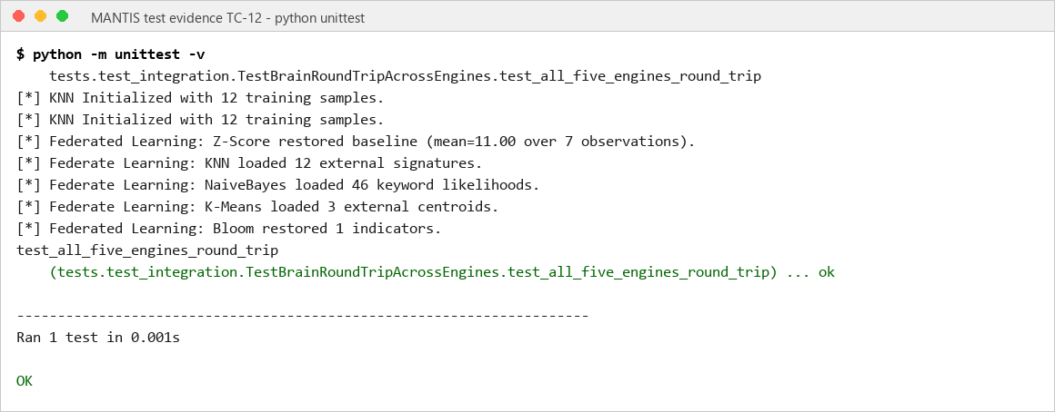
TC-13 | 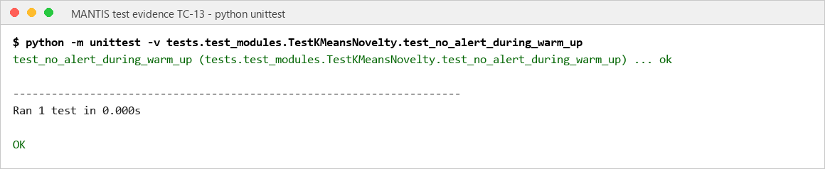
TC-14 | 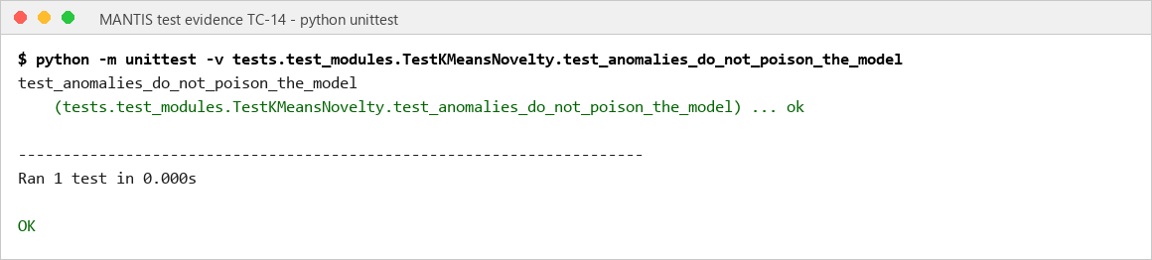
TC-15 | 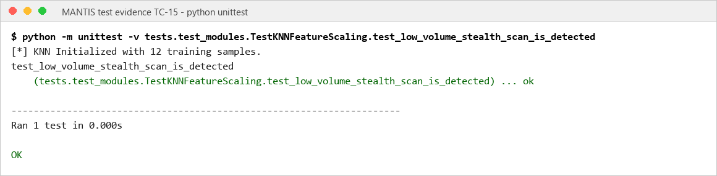
TC-16 | 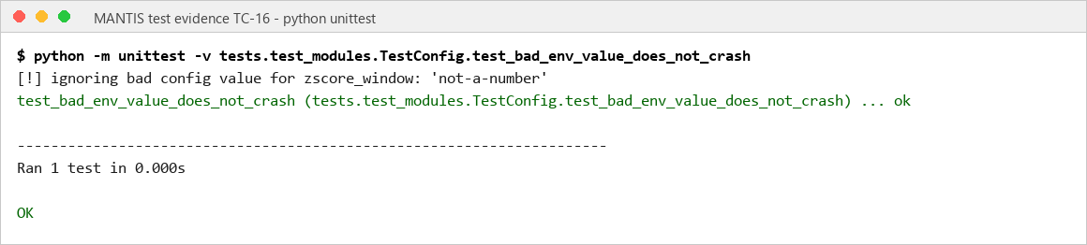
TC-17 | 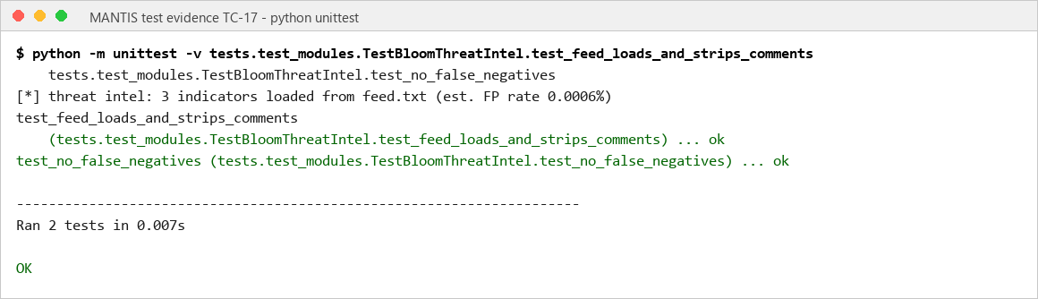
TC-18 | 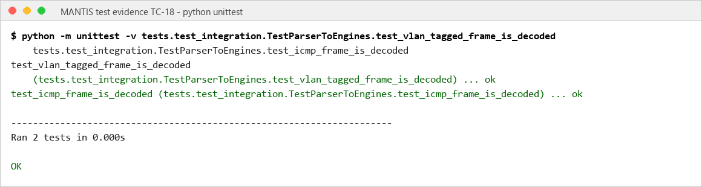
TC-19 | 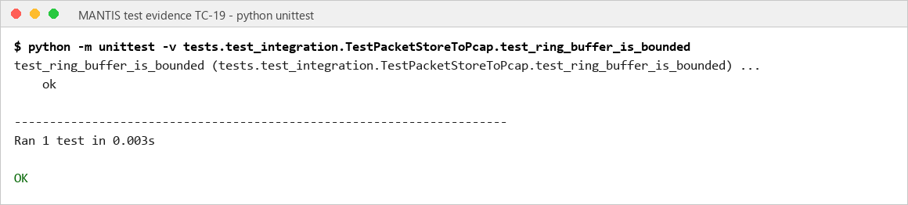
TC-20 | 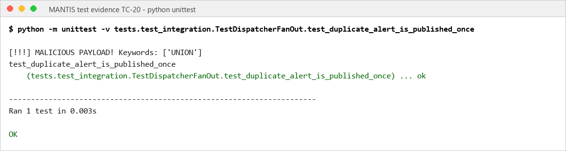
TC-21 | 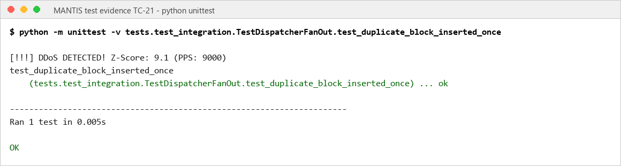
TC-22 | 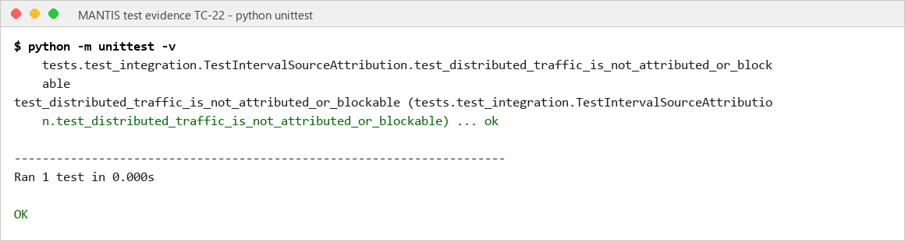
TC-23 | 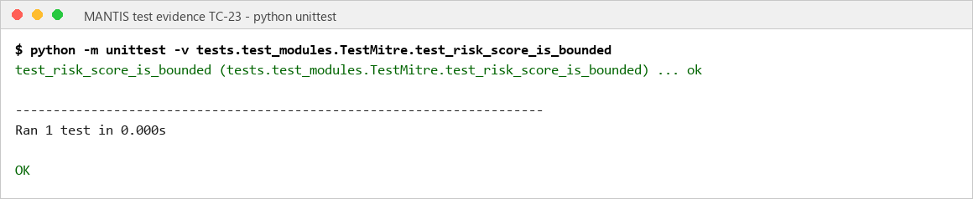
TC-24 | 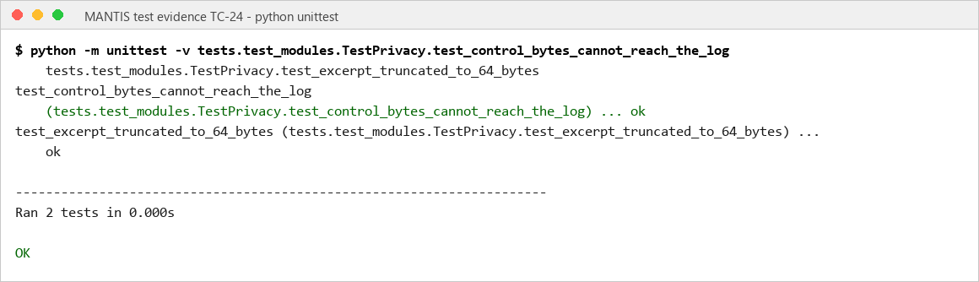
TC-25 | 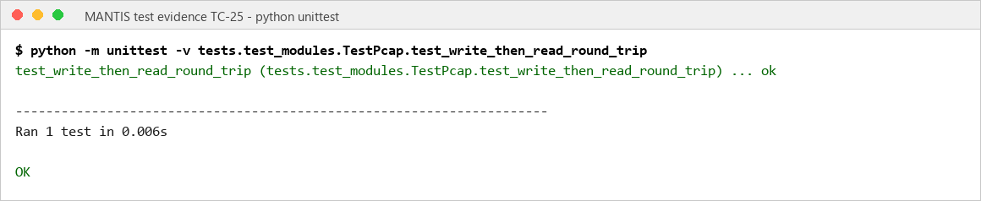
TC-26 | 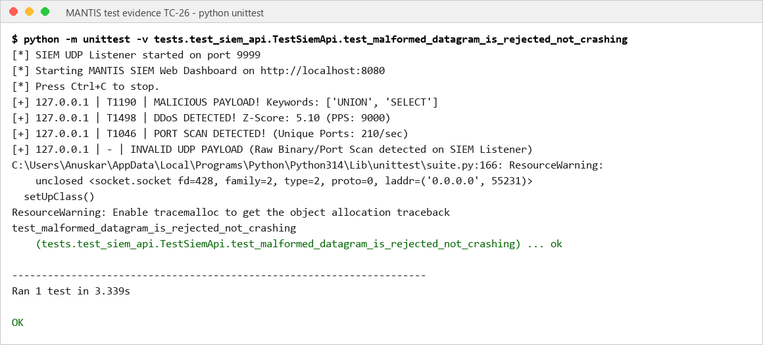
TC-27 | 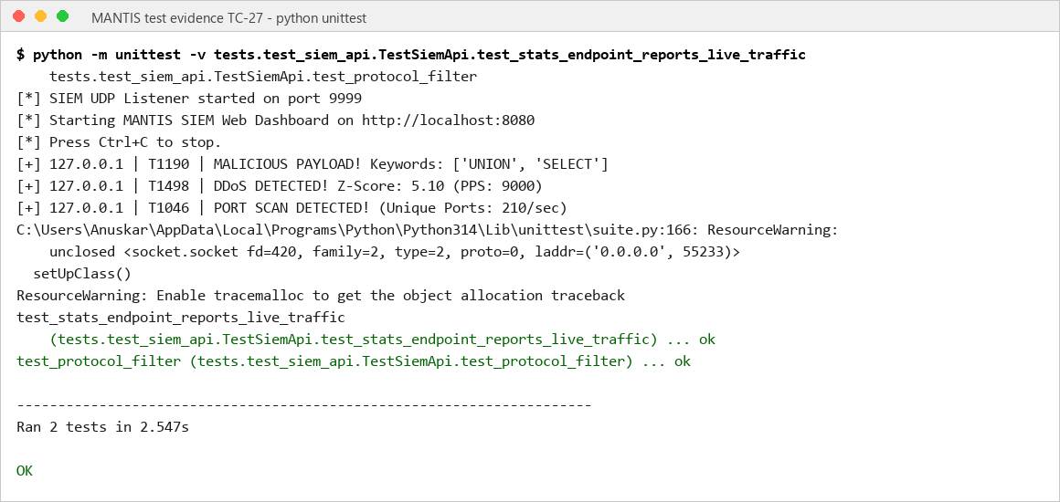
TC-28 | 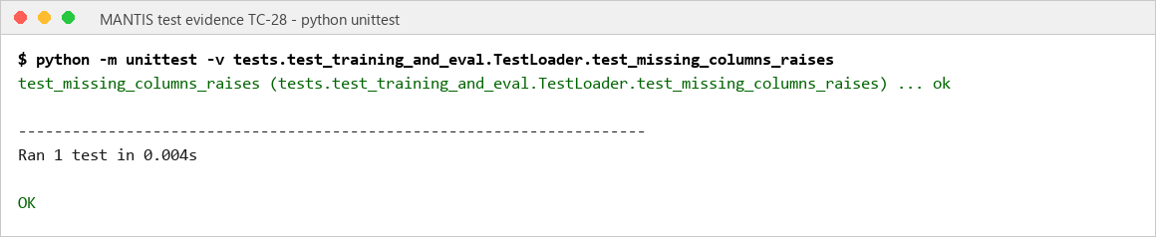

6. Future Scope
Technical scaling should move hot-path counters into eBPF/XDP while retaining Python orchestration. Encrypted-traffic coverage should use flow metadata rather than interception. IPv6 parsing, authenticated dashboard access and TLS-protected telemetry are required before internet-facing deployment.

The 45,018,252-row result makes calibration a priority: replace fixed three-sigma assumptions with streaming quantiles, construct genuine temporal windows and evaluate class-balanced device, time and attack-family splits. Deployment should progress from supervised laboratory use, to an isolated management VLAN with blocking disabled, and finally to policy-gated blocking after false-positive comparison with Snort or Suricata on the same traffic.

7. Conclusion
MANTIS met its aim by delivering an inspectable host detector for commodity Linux using AF_PACKET/PCAP capture, five Standard Library engines, CSV/JSON evidence and optional iptables response. On 20 August 2026 all 116 automated tests passed in 4.642 seconds, tracing capture, classification, privacy, persistence, SIEM delivery and policy-gated blocking.

The literature gaps became design constraints: transparent decisions, explicit feature validation, an integrated packet pipeline and separation of software verification from detection effectiveness. The 63-file CIC-IoT2023 stress test confirmed the importance of that separation. Precision was 0.997417, but recall 0.043619, F1 0.083582 and MCC 0.029049 showed weak transfer from a controlled three-sigma rule to heavy-tailed flow data. This negative result is more credible than the perfect constructed checks and prevents a production-accuracy claim. Relative to Snort, Suricata, Zeek and Wazuh, MANTIS remains a focused Linux and plaintext research prototype.

MANTIS meets the dissertation aim as a transparent research prototype, not an enterprise replacement. Future work should use independent, prevalence-balanced temporal traffic, add IPv6 and richer parsing, close test sockets deterministically, and compare resource use and alert quality with established systems under one workload. Lightweight intrusion detection is credible only when algorithm assumptions, controls and evidence limits remain visible.

8. References
- Cisco Talos (2024) Snort. [online] Available from: https://www.snort.org/ [Accessed 4 August 2026].
- Crnkovic, G. (2010) Constructive research and info computational knowledge generation. In: Magnani, L., Carnielli, W. and Pizzi, C. (eds.) Model Based Reasoning in Science and Technology. Berlin: Springer, pp. 359 to 380.
- Halvorsen, J., Izurieta, C., Cai, H. and Gebremedhin, A. (2024) Applying generative machine learning to intrusion detection: a systematic mapping study and review. ACM Computing Surveys, 56(10), article 257. Available from: https://doi.org/10.1145/3659575 [Accessed 18 June 2026].
- Hidayat, I., Ali, M.Z. and Arshad, A. (2023) Machine learning based intrusion detection system: an experimental comparison. Journal of Computational and Cognitive Engineering, 2(2), pp. 88 to 97. Available from: https://doi.org/10.47852/bonviewJCCE2202270 [Accessed 8 March 2026].
- Kus, D., Wagner, E., Pennekamp, J., Wolsing, K., Fink, I.B., Dahlmanns, M., Wehrle, K. and Henze, M. (2022) A false sense of security? Revisiting the state of machine learning based industrial intrusion detection. In: Proceedings of the 8th ACM Cyber Physical System Security Workshop (CPSS ’22). New York: ACM. Available from: https://doi.org/10.1145/3494107.3522773 [Accessed 19 August 2026].
- Mitzenmacher, M. and Upfal, E. (2017) Probability and Computing: Randomization and Probabilistic Techniques in Algorithms and Data Analysis. 2nd ed. Cambridge: Cambridge University Press.
- Neto, E.C.P., Dadkhah, S., Ferreira, R., Zohourian, A., Lu, R. and Ghorbani, A.A. (2023) CICIoT2023: a real time dataset and benchmark for large scale attacks in IoT environment. Sensors, 23(13), 5941. Available from: https://doi.org/10.3390/s23135941 [Accessed 10 May 2026].
- National Institute of Standards and Technology (2007) Guide to Intrusion Detection and Prevention Systems (IDPS). NIST Special Publication 800-94. Gaithersburg: NIST.
- OISF (2024) Suricata user guide. [online] Available from: https://docs.suricata.io/ [Accessed 11 March 2026].
- Python Software Foundation (2026) Python 3 documentation. [online] Available from: https://docs.python.org/3/ [Accessed 17 July 2026].
- Sculley, D. (2010) Web scale k-means clustering. In: Proceedings of the 19th International Conference on World Wide Web (WWW 2010). New York: ACM, pp. 1177 to 1178.
- Sommer, R. and Paxson, V. (2010) Outside the closed world: on using machine learning for network intrusion detection. In: IEEE Symposium on Security and Privacy. Los Alamitos: IEEE, pp. 305 to 316.
- Wazuh (2026) Wazuh documentation. [online] Available from: https://documentation.wazuh.com/current/ [Accessed 11 July 2026].
- Zeek Project (2026) Zeek documentation. [online] Available from: https://docs.zeek.org/ [Accessed 27 April 2026].

Appendix A: Gantt Chart
The Gantt chart retains the interim weekly layout while aligning the schedule to constructive research: problem definition, requirements, design, construction, evaluation, critique and dissertation completion.
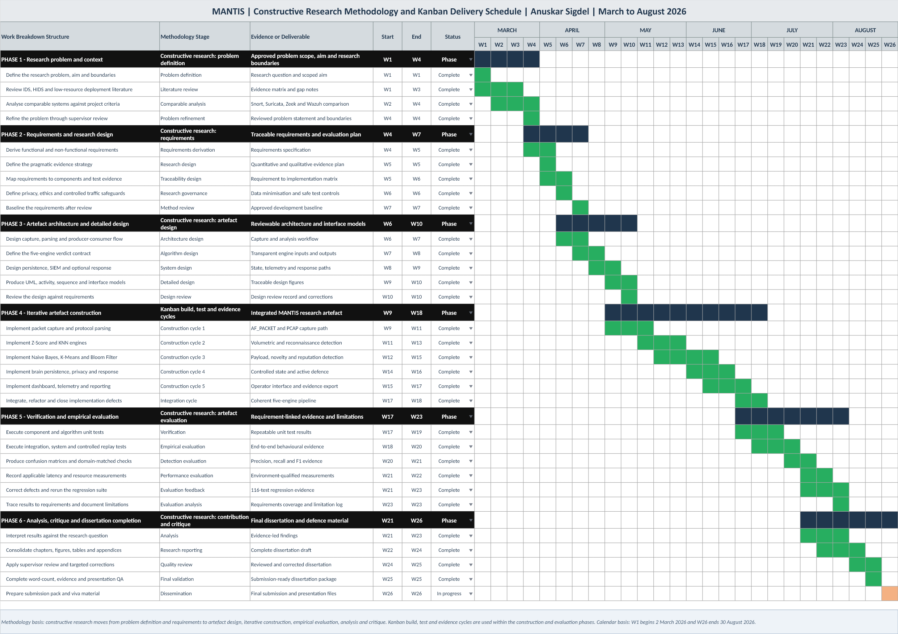
Figure A.1: MANTIS constructive research methodology Gantt chart

Appendix B: Supervisor Meeting Forms
The signed project diary and log forms below record the supervision meetings held during the project, continuing the log presented in the interim report.
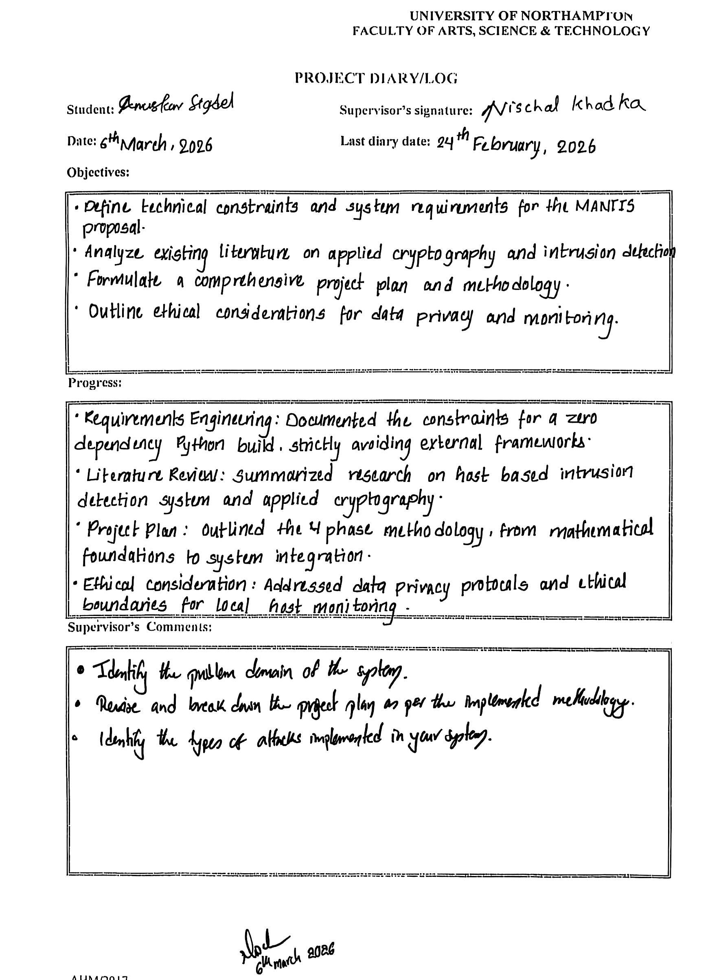
Figure B.1: Supervisor meeting form, project diary and log (1 of 2)

Figure B.2: Supervisor meeting form, project diary and log (2 of 2)

Appendix C: Source Code

Appendix D: Presentation Slide

